**/*ASSIGNMENT 1*/**

**/* USE HR */**

USE HR;

/*SHOW TABLES;*/

SHOW TABLES;

/*SHOW employees*/

SELECT

*

FROM

EMPLOYEES;

/* 1 Write a query to display the names (first_name, last_name) using alias name “First Name", "Last

Name"*/

USE HR;

SHOW TABLES;

select* FROM EMPLOYEES;

SELECT

FIRST_NAME AS 'FIRST NAME', LAST_NAME AS 'LAST NAME'

FROM

EMPLOYEES;

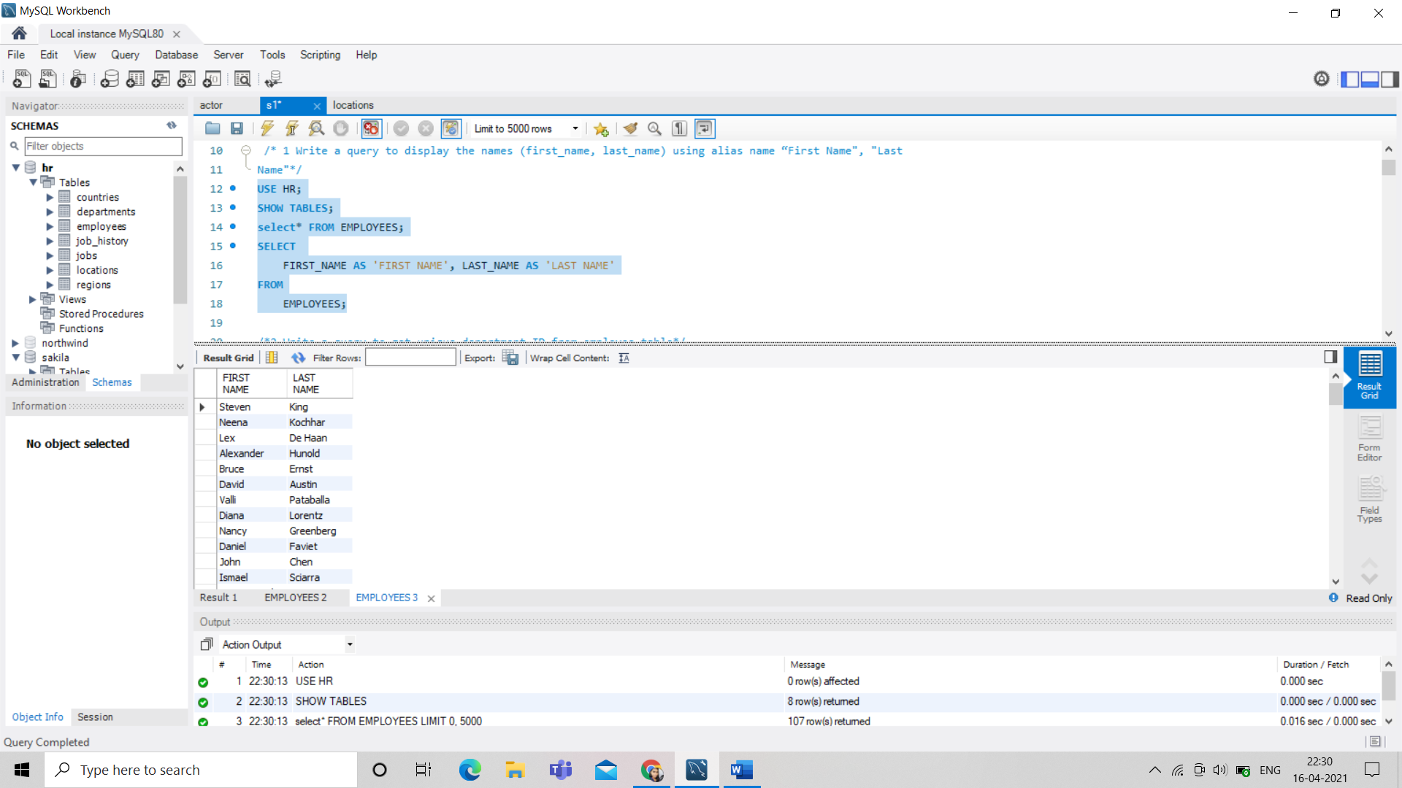

/*2.Write a query to get unique department ID from employee table*/

SELECT DISTINCT

department_id

FROM

departments;

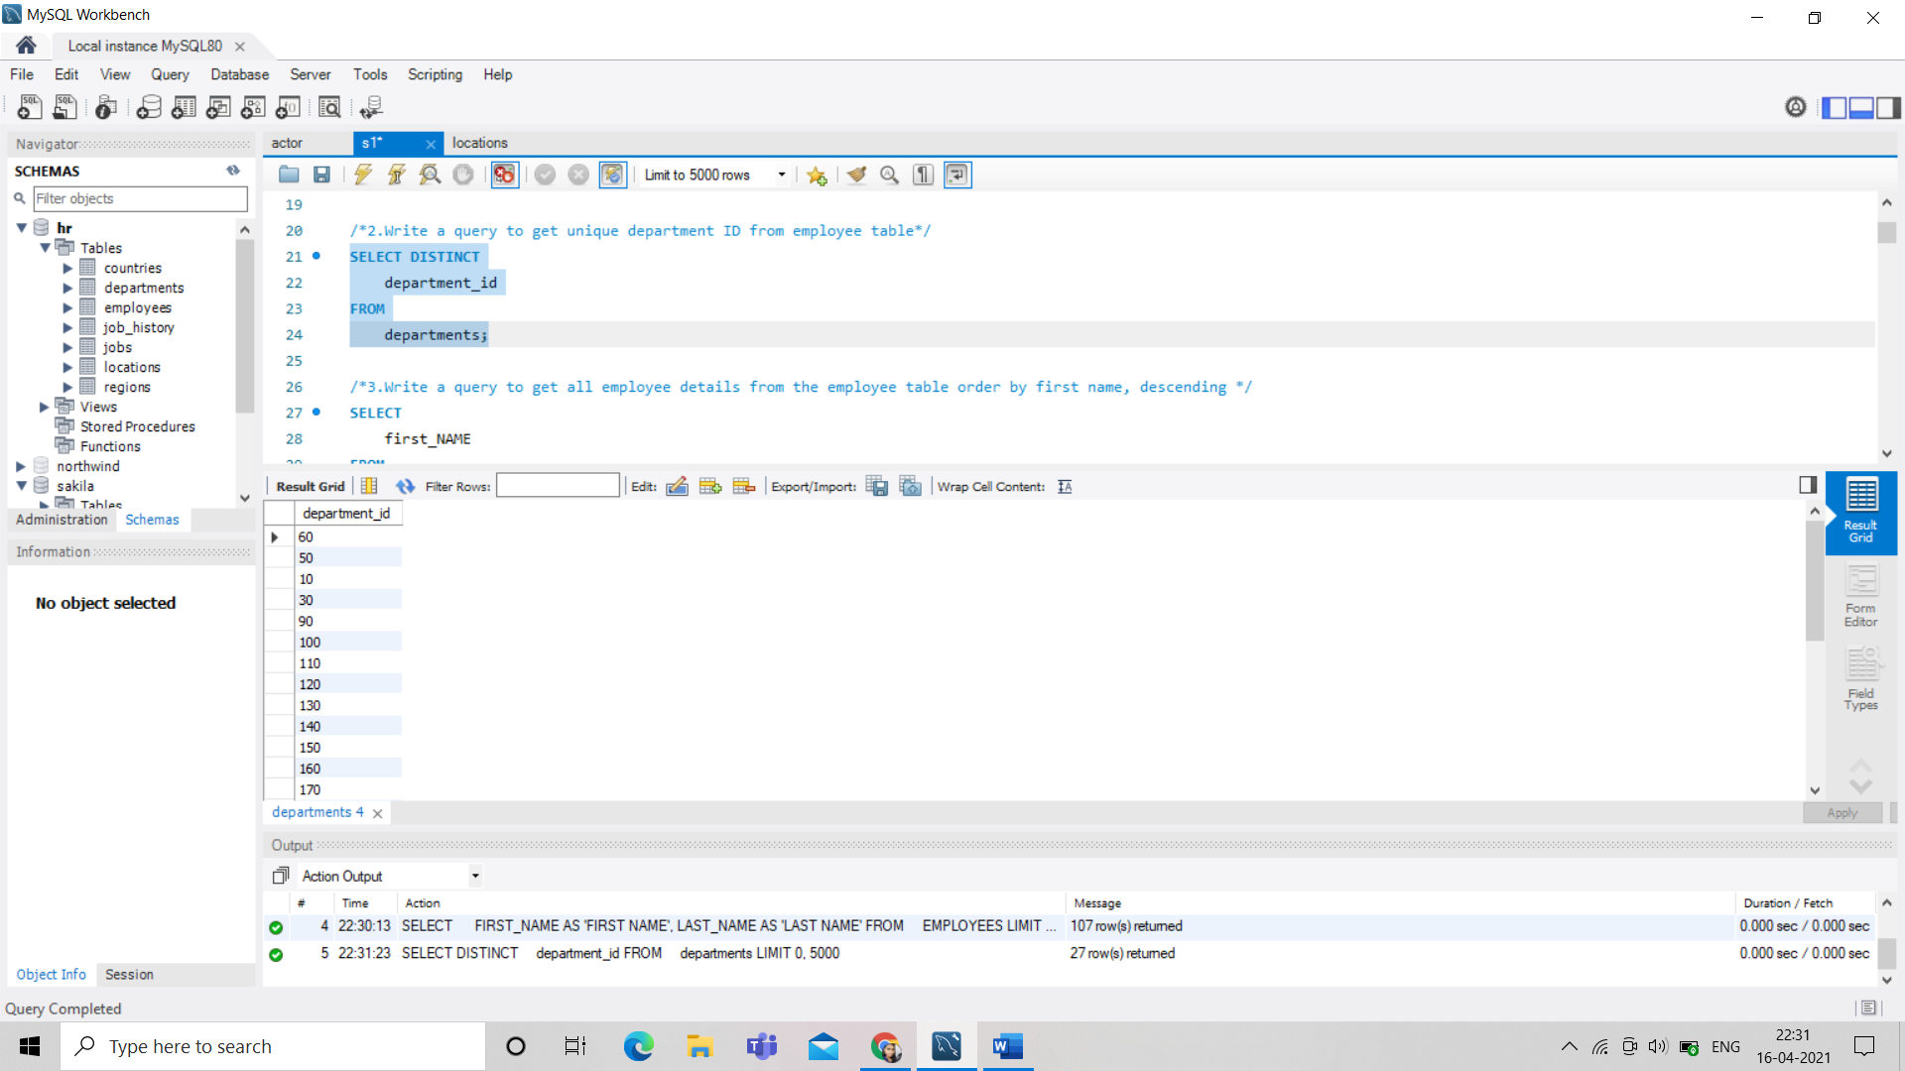

/*3.Write a query to get all employee details from the employee table order by first name, descending */

SELECT

first_NAME

FROM

EMPLOYEES

ORDER BY first_name DESC;

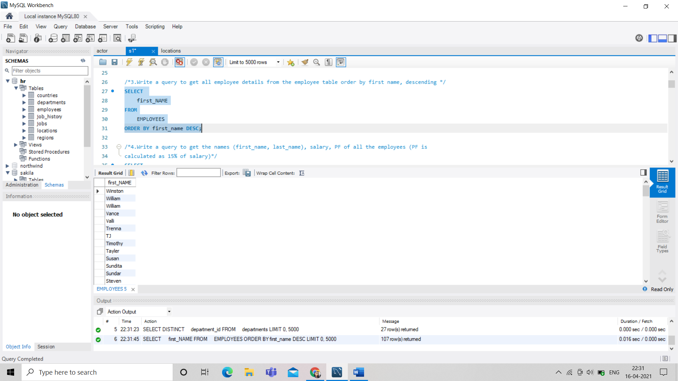

/*4.Write a query to get the names (first_name, last_name), salary, PF of all the employees (PF is

calculated as 15% of salary)*/

SELECT

first_name, last_name, salary, salary * .15 PF

FROM

employees;

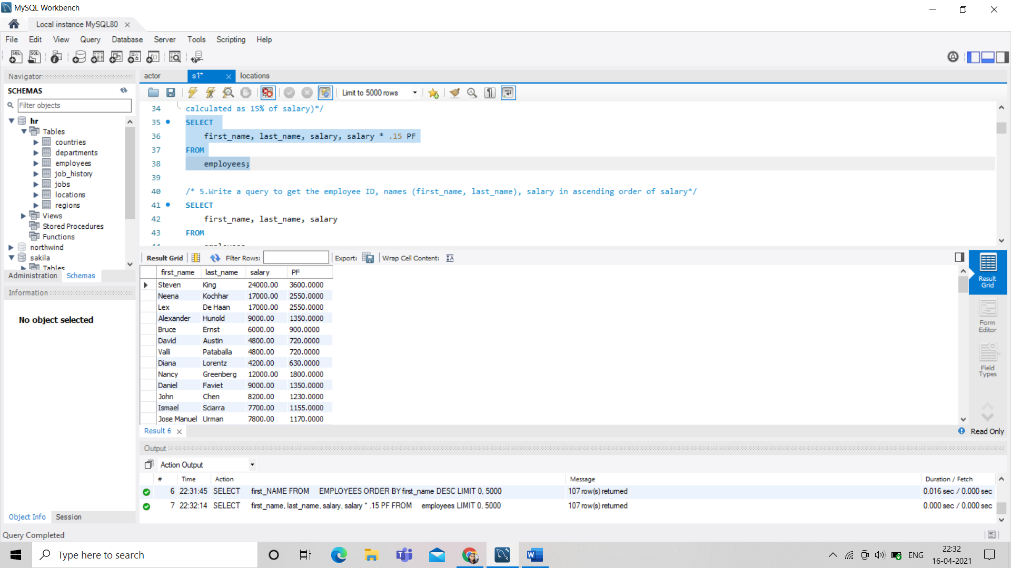

/* 5.Write a query to get the employee ID, names (first_name, last_name), salary in ascending order of salary*/

SELECT

first_name, last_name, salary

FROM

employees

ORDER BY salary ASC;

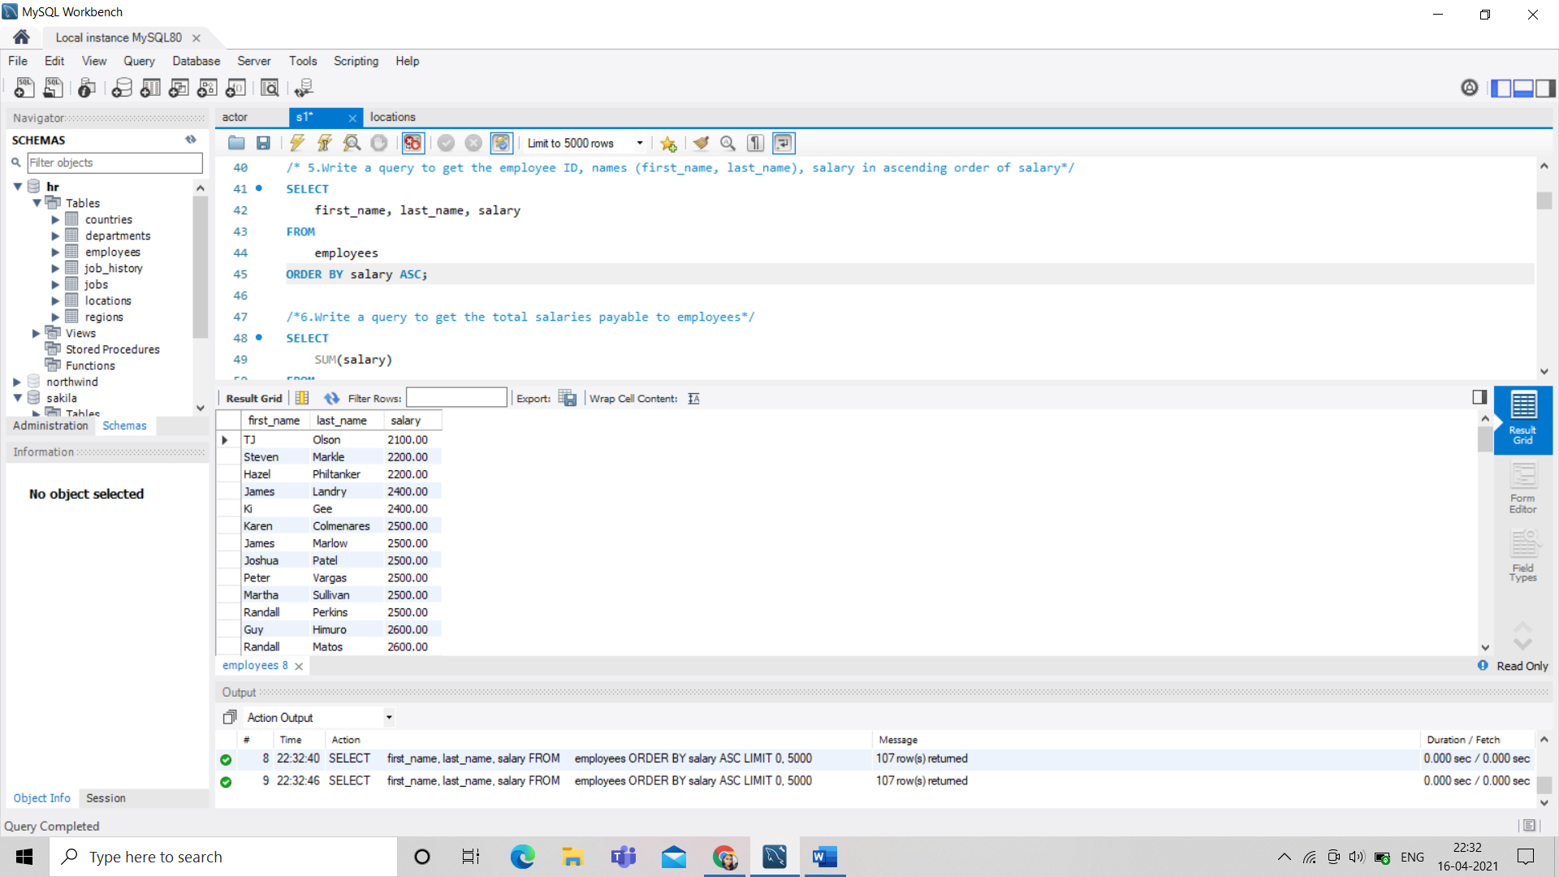

/*6.Write a query to get the total salaries payable to employees*/

SELECT

SUM(salary)

FROM

employees;

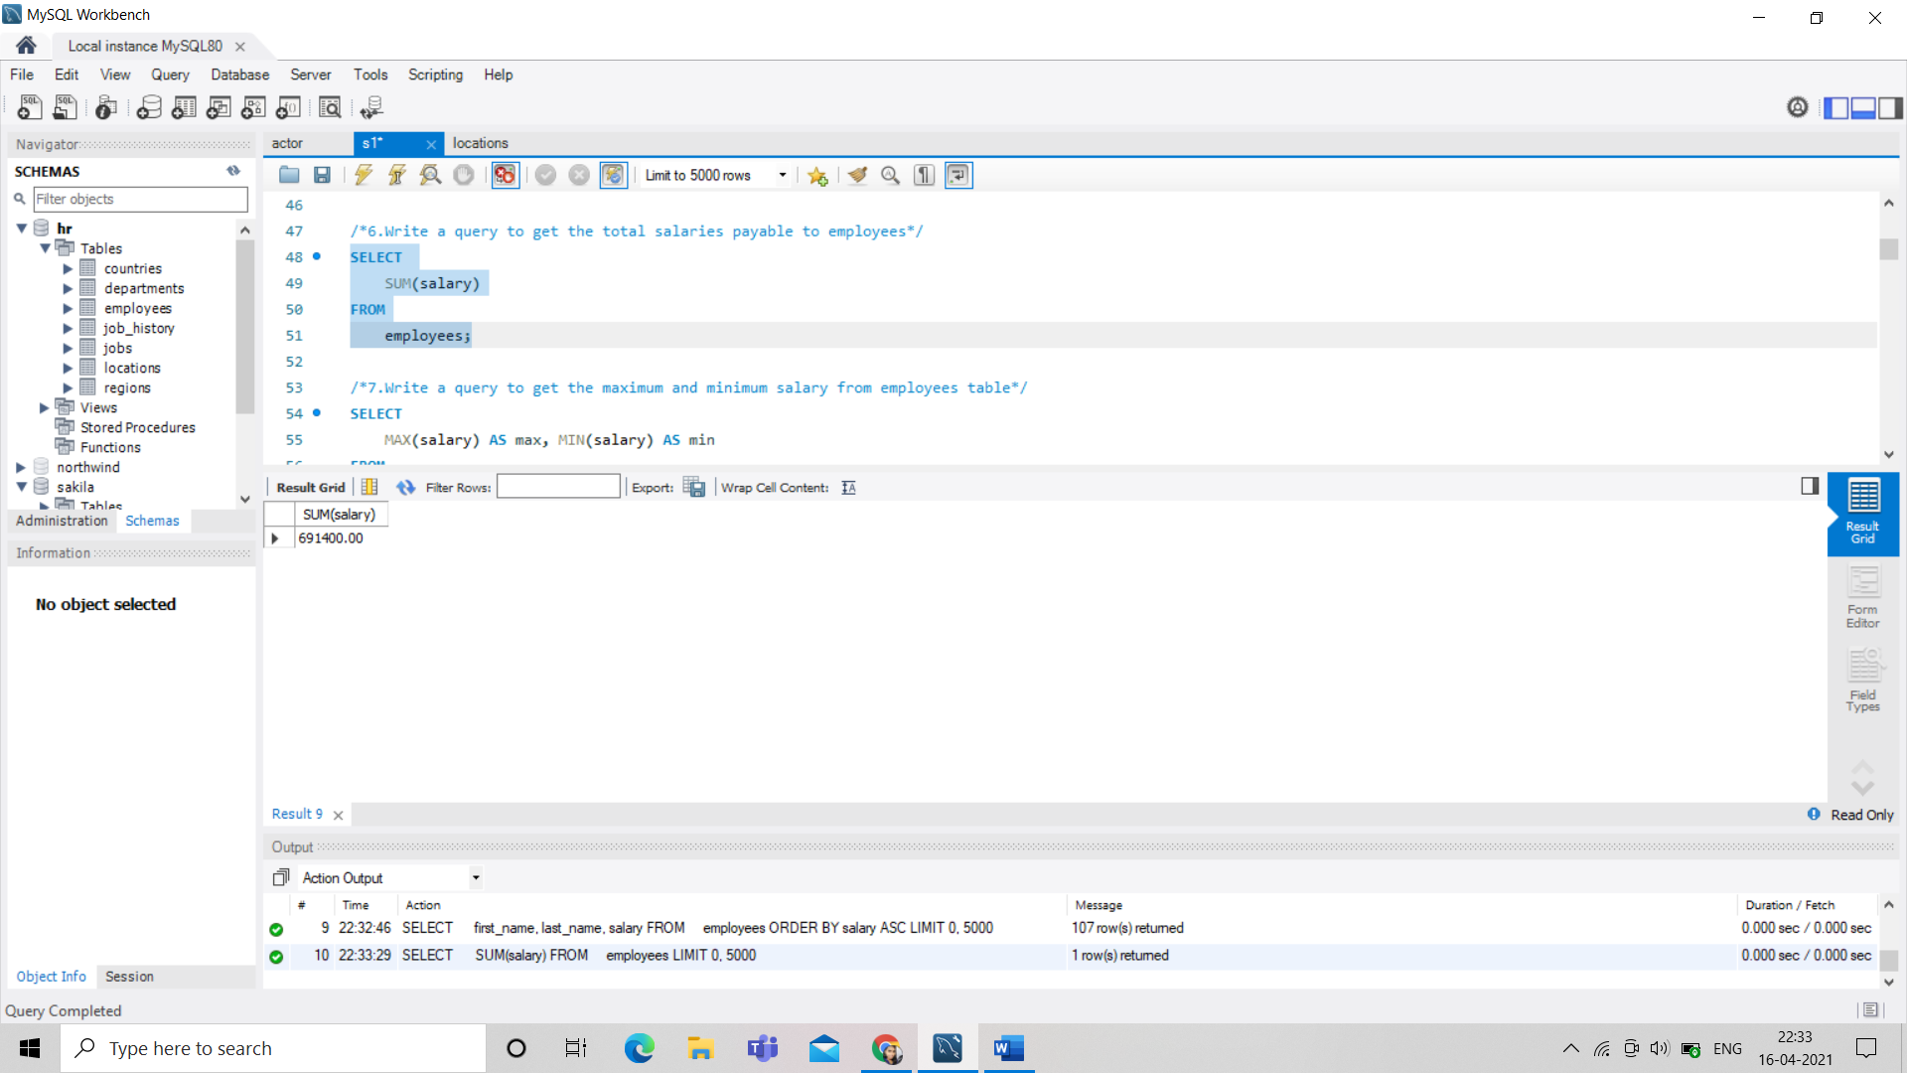

/*7.Write a query to get the maximum and minimum salary from employees table*/

SELECT

MAX(salary) AS max, MIN(salary) AS min

FROM

employees;

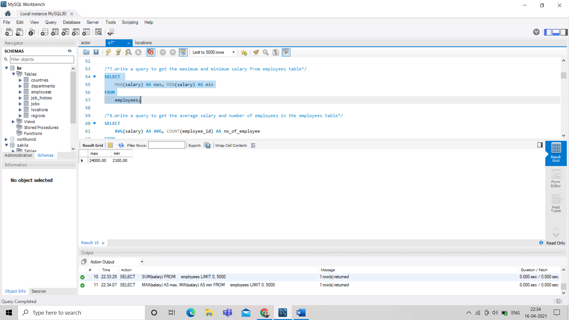

/*8.Write a query to get the average salary and number of employees in the employees table*/

SELECT

AVG(salary) AS AVG, COUNT(employee_id) AS no_of_employee

FROM

employees;

SELECT COUNT(*)

FROM employees;

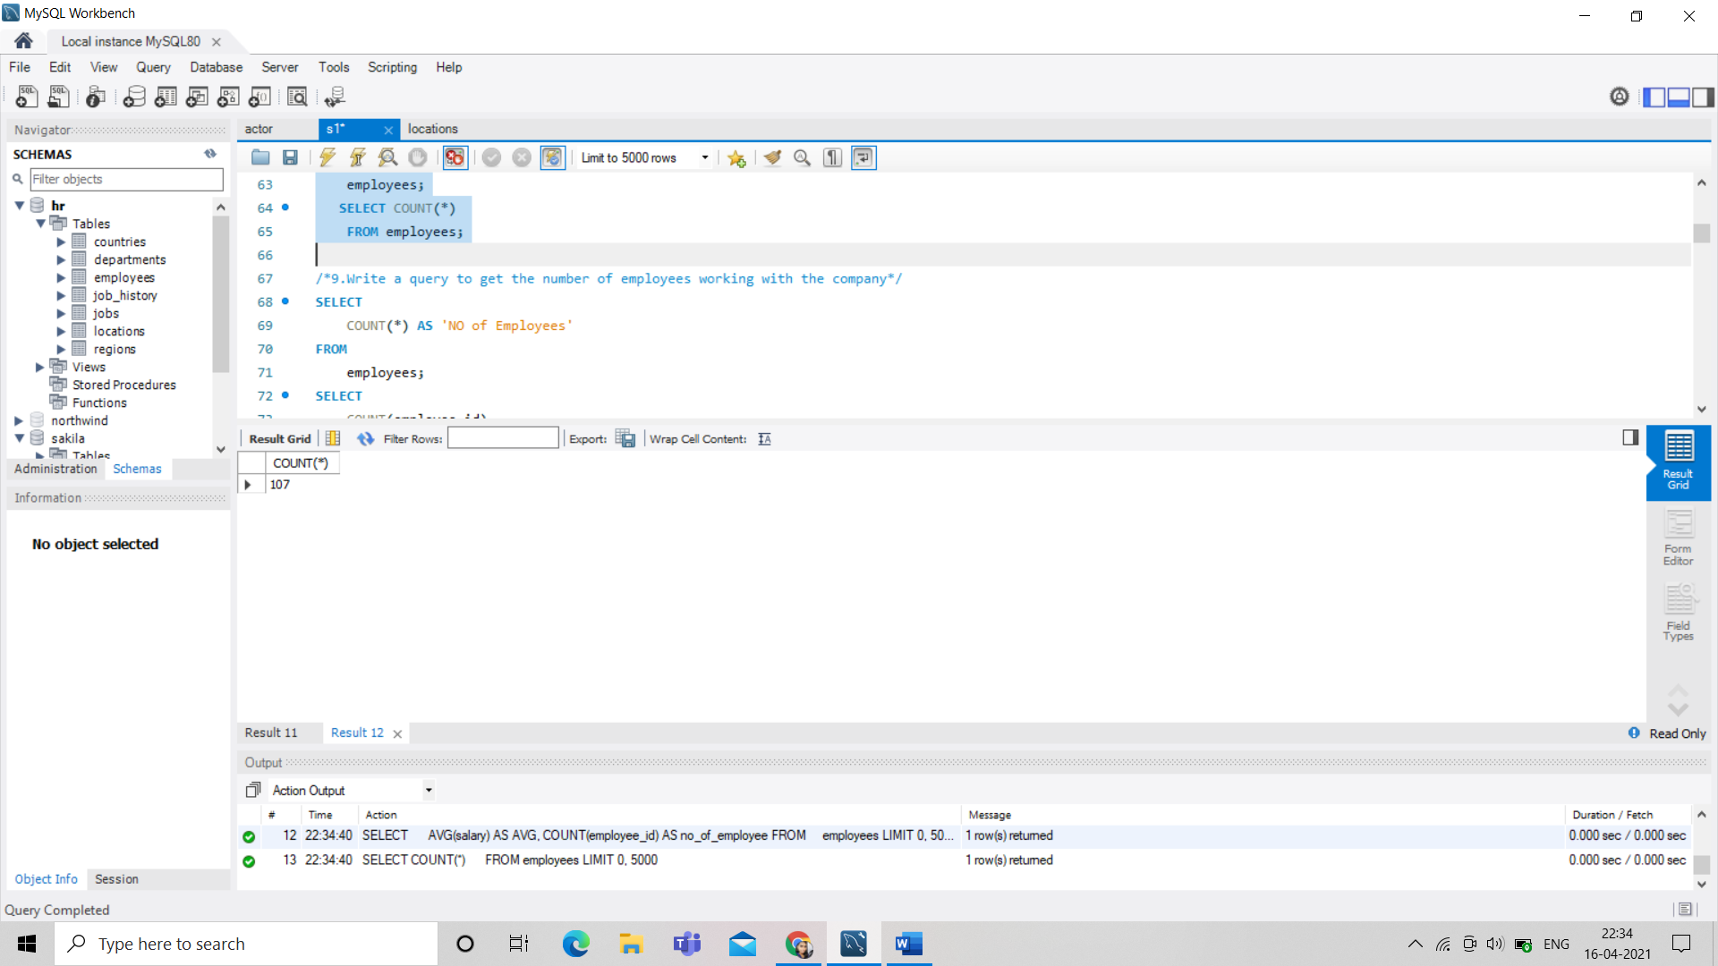

/*9.Write a query to get the number of employees working with the company*/

SELECT

COUNT(*) AS 'NO of Employees'

FROM

employees;

SELECT

COUNT(employee_id)

FROM

employees;

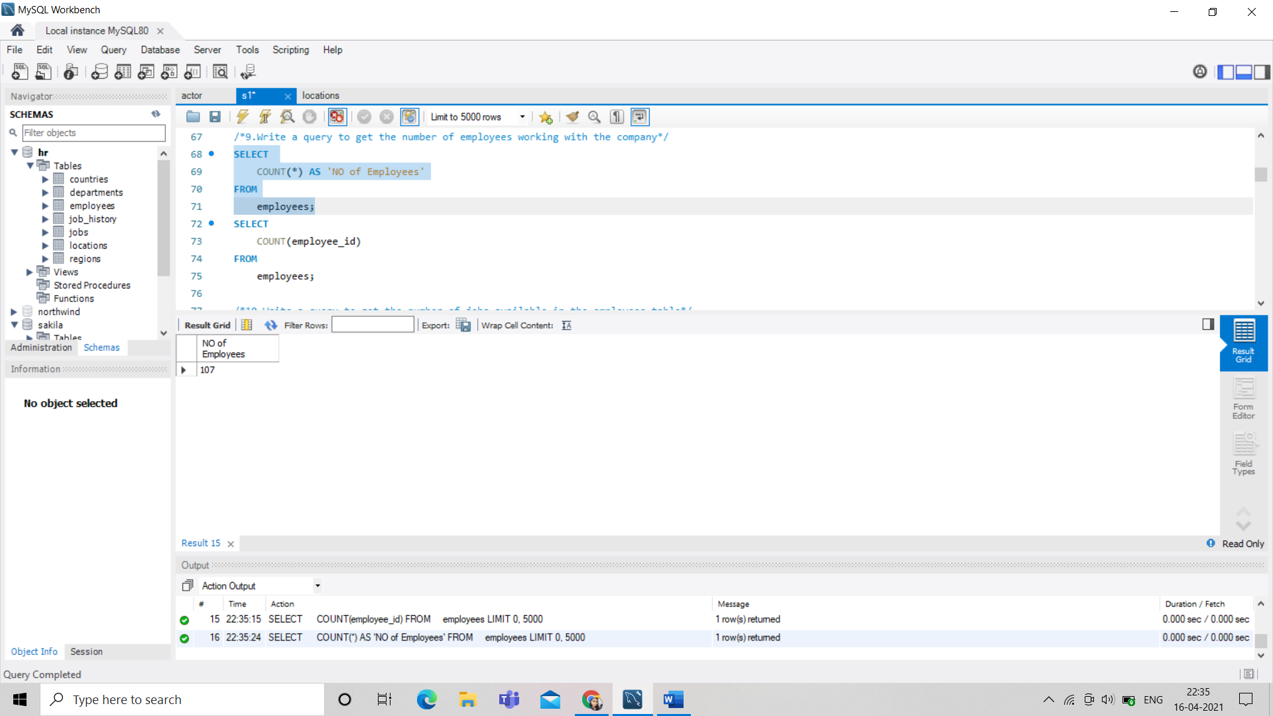

/*10.Write a query to get the number of jobs available in the employees table*/

SELECT COUNT(DISTINCT job_id) FROM employees; 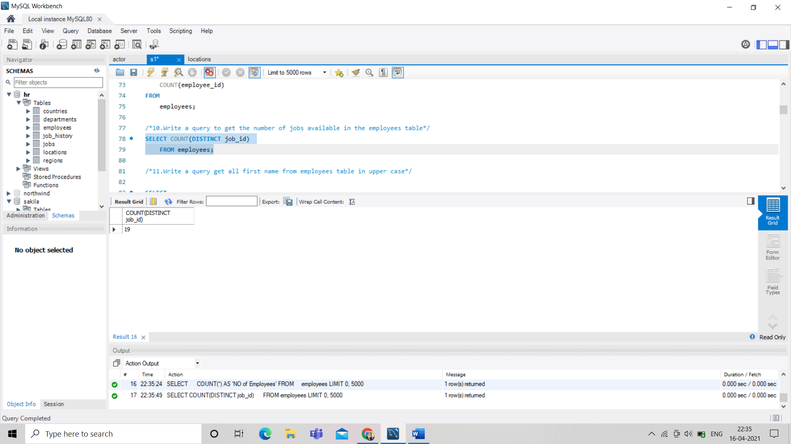

/*11.Write a query get all first name from employees table in upper case*/

SELECT

UPPER(first_name) AS 'UPPER CASE'

FROM

employees;

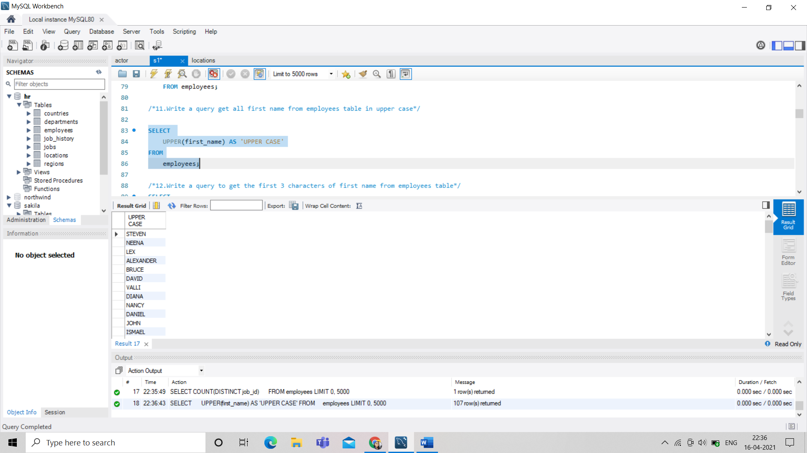

/*12.Write a query to get the first 3 characters of first name from employees table*/

SELECT

LEFT(first_name, 3)

FROM

employees;

SELECT

SUBSTRING(first_name, 1, 3)

FROM

employees;

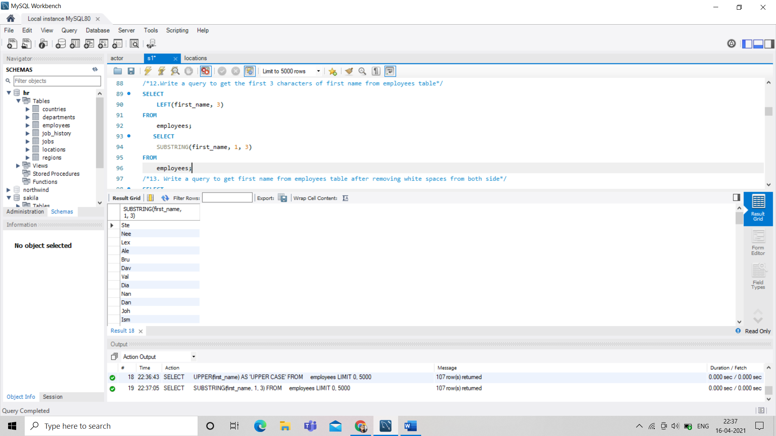

/*13. Write a query to get first name from employees table after removing white spaces from both side*/

SELECT

TRIM(first_name) AS 'Removing Spaces from both side'

FROM

employees;

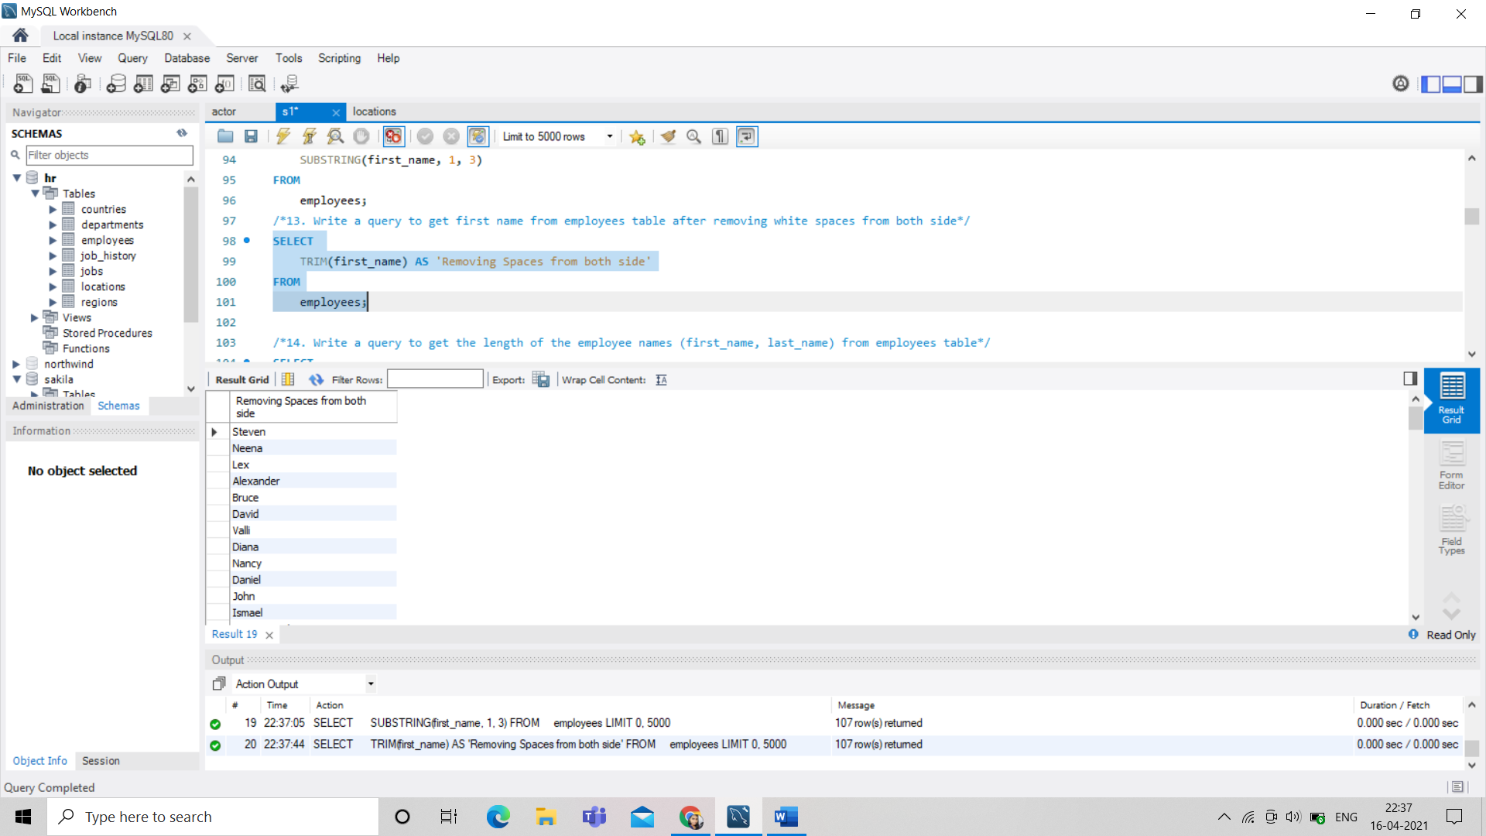

/*14. Write a query to get the length of the employee names (first_name, last_name) from employees table*/

SELECT

first_name,

last_name,

CONCAT(last_name, ', ', first_name) AS full_name,

LENGTH(CONCAT(last_name, ', ', first_name)) AS len_full_name

FROM

employees;

SELECT

first_name,

last_name,

LENGTH(first_name) + LENGTH(last_name) AS 'Length of Names'

FROM

employees;

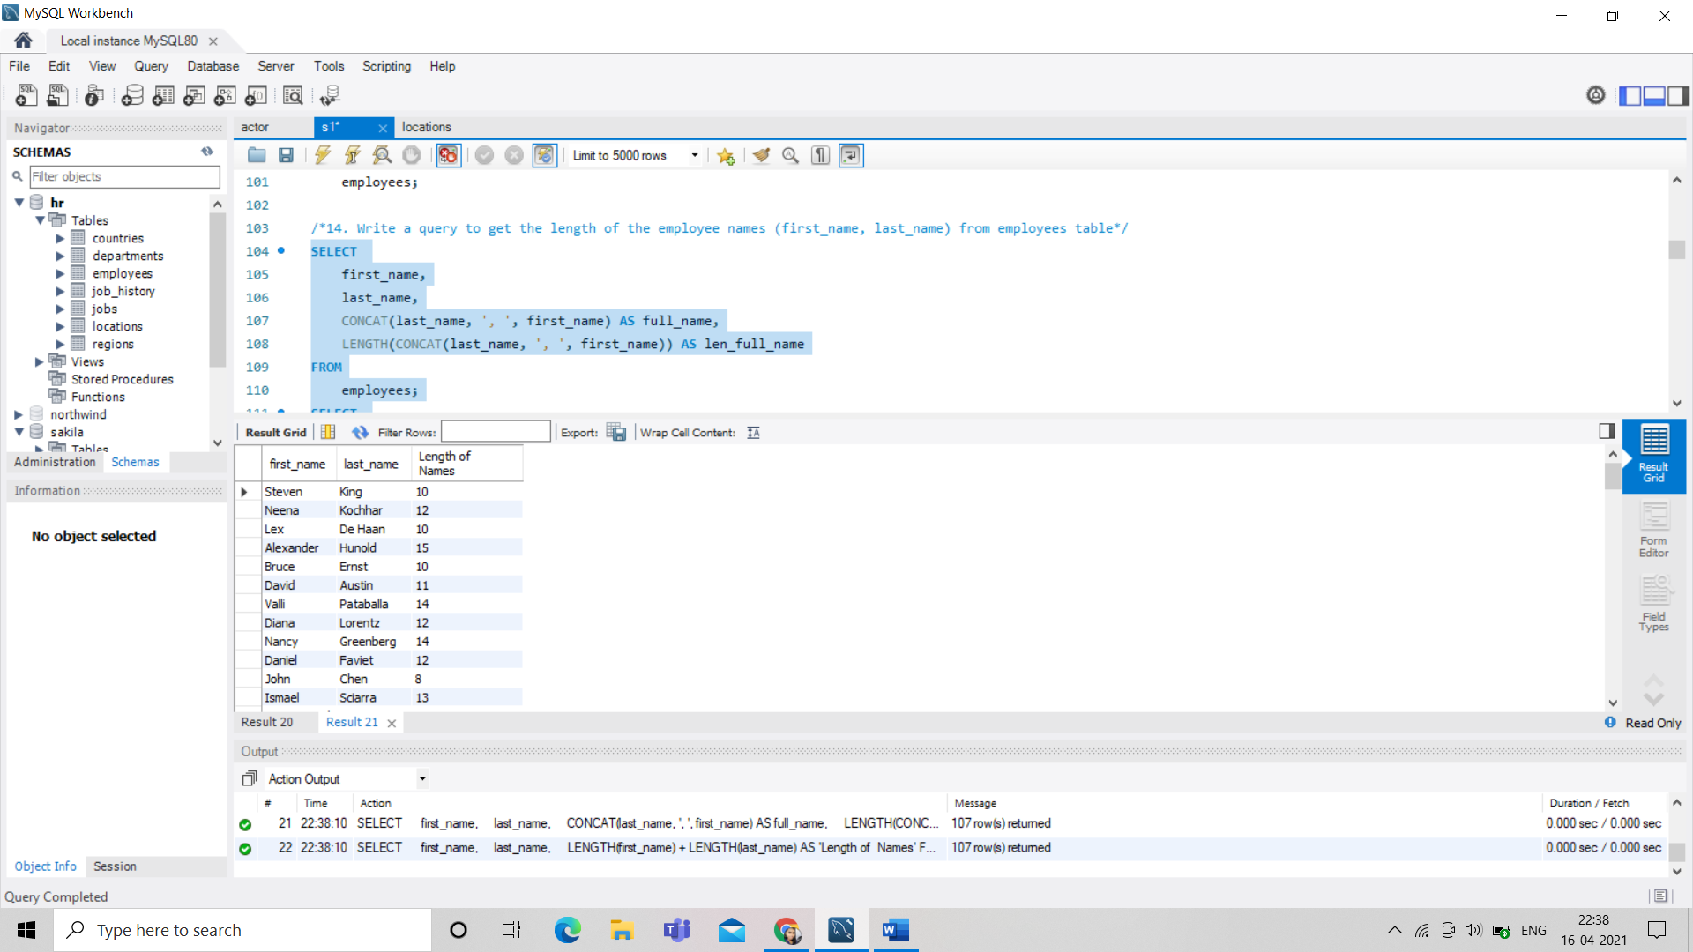

/*15. Write a query to check if the first_name fields of the employees table contains numbers*/

SELECT *

FROM employees

WHERE first_name REGEXP '[0-9]';

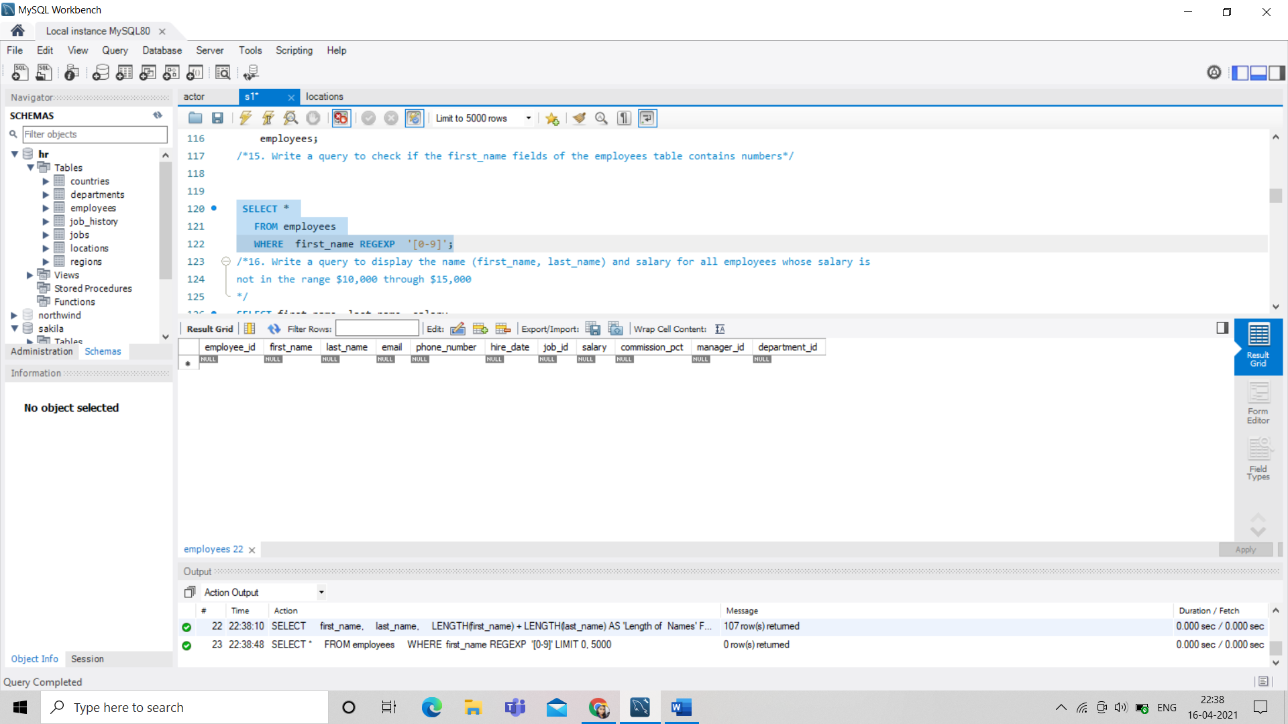

/*16. Write a query to display the name (first_name, last_name) and salary for all employees whose salary is

not in the range $10,000 through $15,000

*/

SELECT first_name, last_name, salary

FROM employees

WHERE salary NOT BETWEEN 10000 AND 15000;

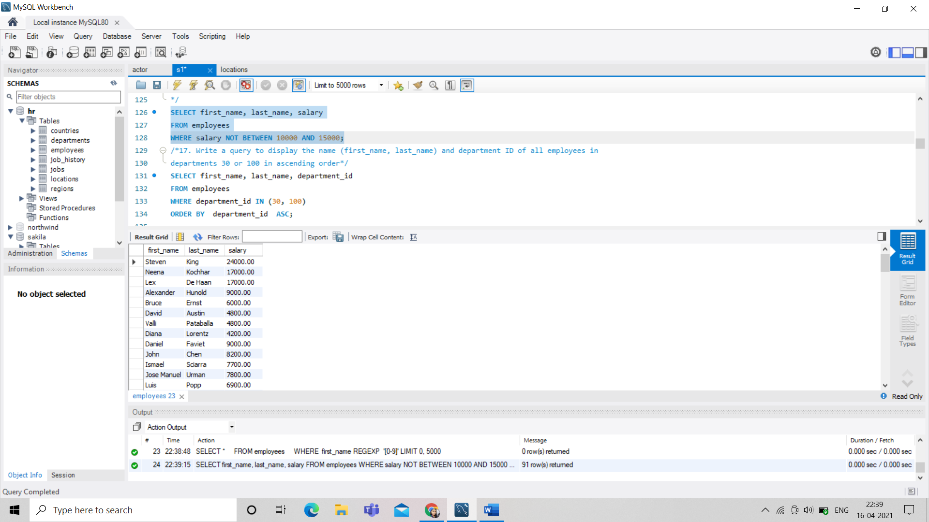

/*17. Write a query to display the name (first_name, last_name) and department ID of all employees in

departments 30 or 100 in ascending order*/

SELECT first_name, last_name, department_id

FROM employees

WHERE department_id IN (30, 100)

ORDER BY department_id ASC;

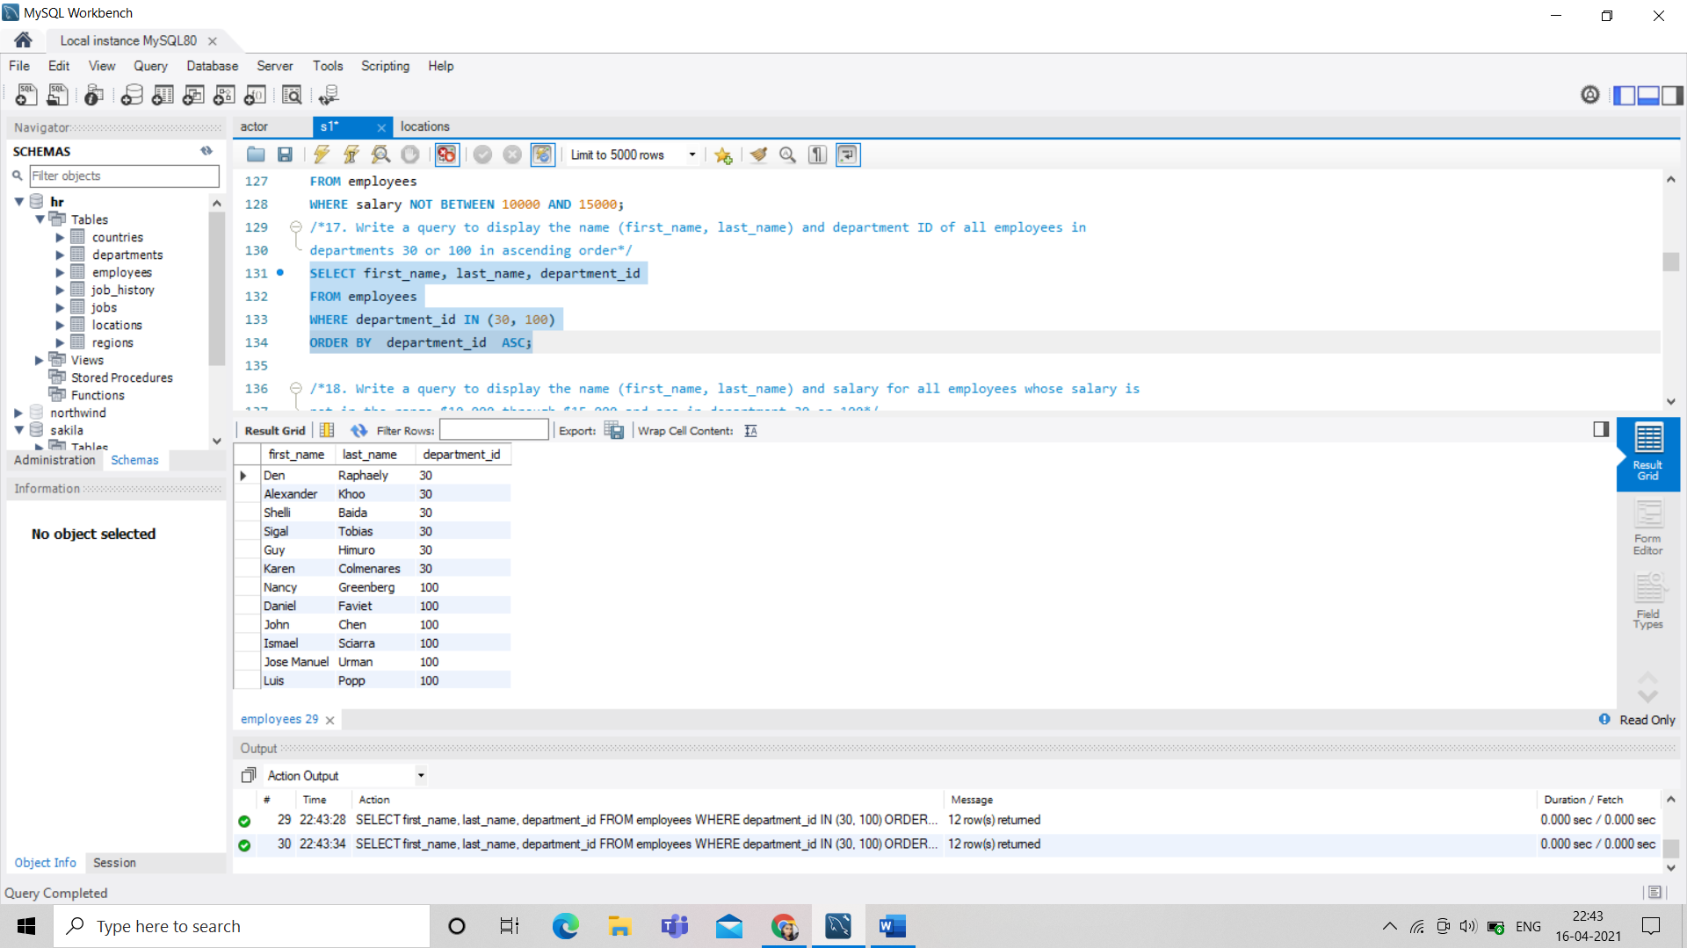

/*18. Write a query to display the name (first_name, last_name) and salary for all employees whose salary is

not in the range $10,000 through $15,000 and are in department 30 or 100*/

SELECT

first_name, last_name, salary

FROM

employees

WHERE

salary NOT BETWEEN 10000 AND 15000

AND department_id IN (30 , 100);

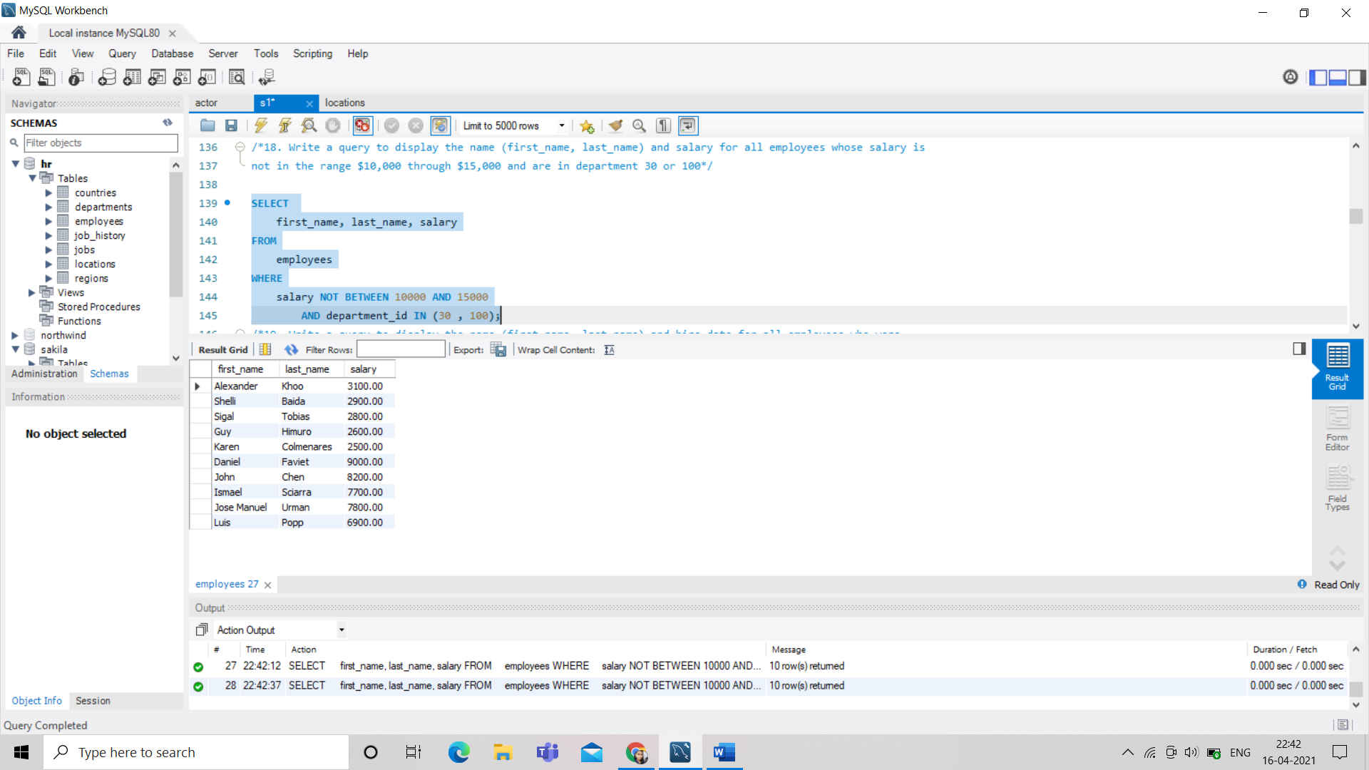

/*19. Write a query to display the name (first_name, last_name) and hire date for all employees who were

hired in 1987

*/

SELECT

first_name, last_name, hire_date

FROM

employees

WHERE

YEAR(hire_date) = 1987;

SELECT

first_name, last_name, hire_date

FROM

employees

WHERE

YEAR(hire_date) IN (1987);

SELECT

first_name, last_name, hire_date

FROM

employees

WHERE

YEAR(hire_date) LIKE 1987;

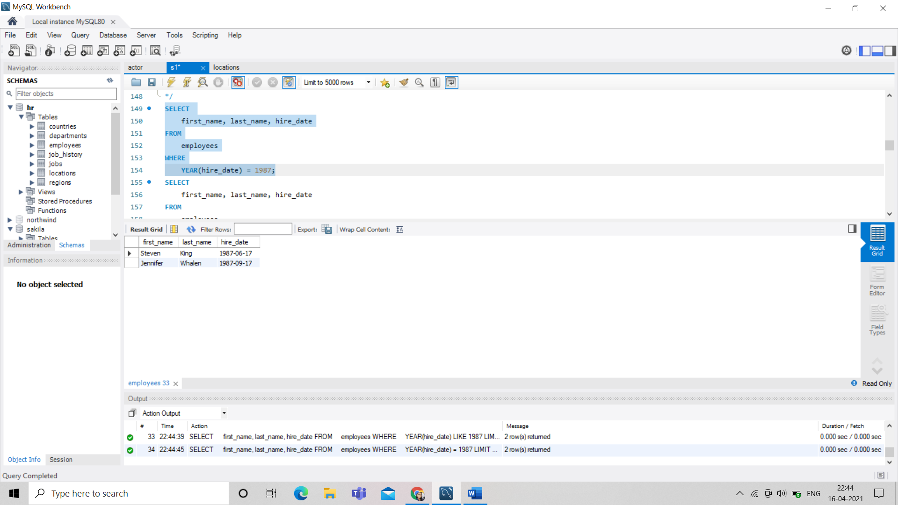

/*20. Write a query to display the first_name of all employees who have both "b" and "c" in their first name*/

SELECT first_name

FROM employees

WHERE first_name LIKE '%b%'

AND first_name LIKE '%c%';

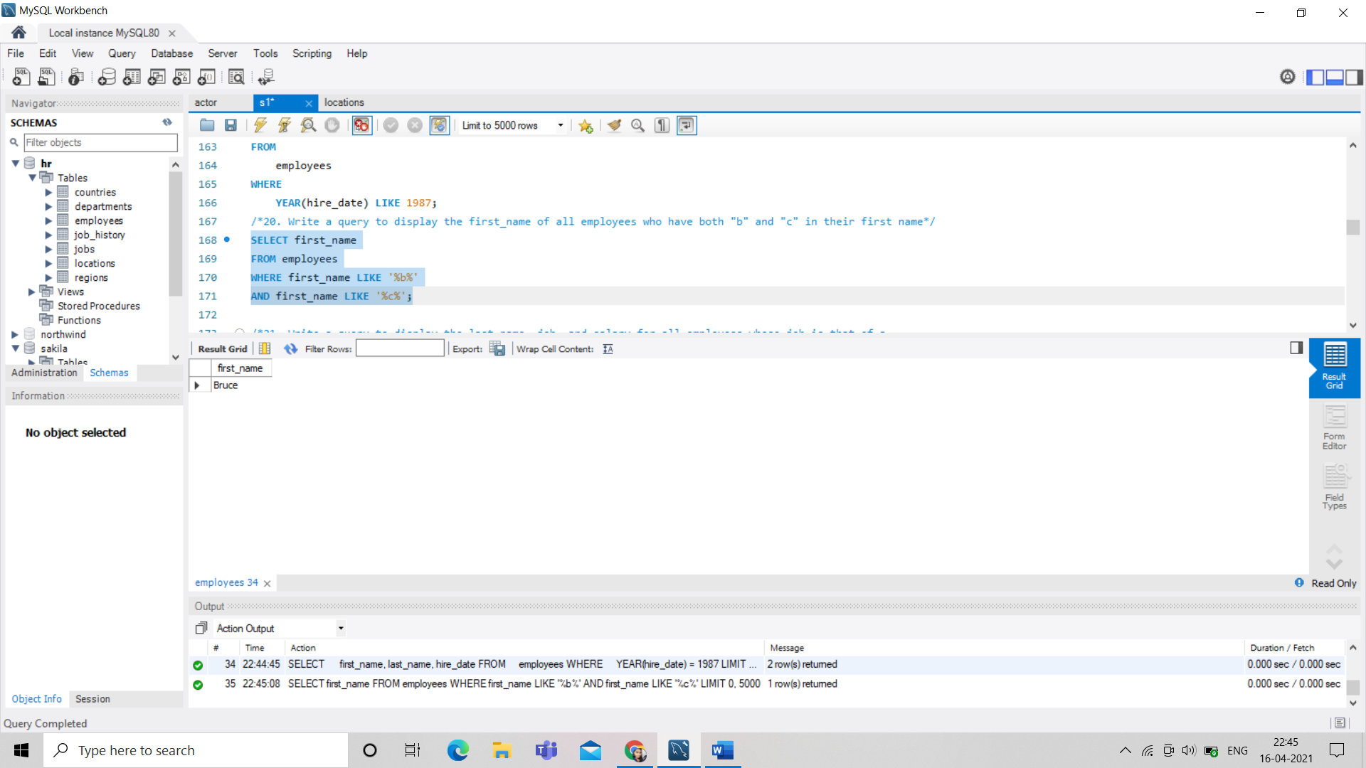

/*21. Write a query to display the last name, job, and salary for all employees whose job is that of a

Programmer or a Shipping Clerk, and whose salary is not equal to $4,500, $10,000, or $15,000*/

SELECT

last_name, job_id, salary

FROM

employees

WHERE

job_id IN ('IT_PROG' , 'ST_CLERK');

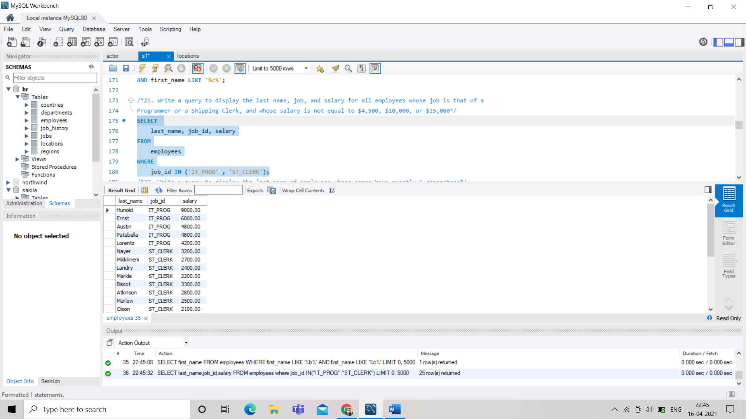

/*22. Write a query to display the last name of employees whose names have exactly 6 characters*/

SELECT

last_name,length(last_name)as len

FROM

employees

WHERE

length(last_name )=6;

SELECT

*

FROM

employees

WHERE

length(last_name )=6;

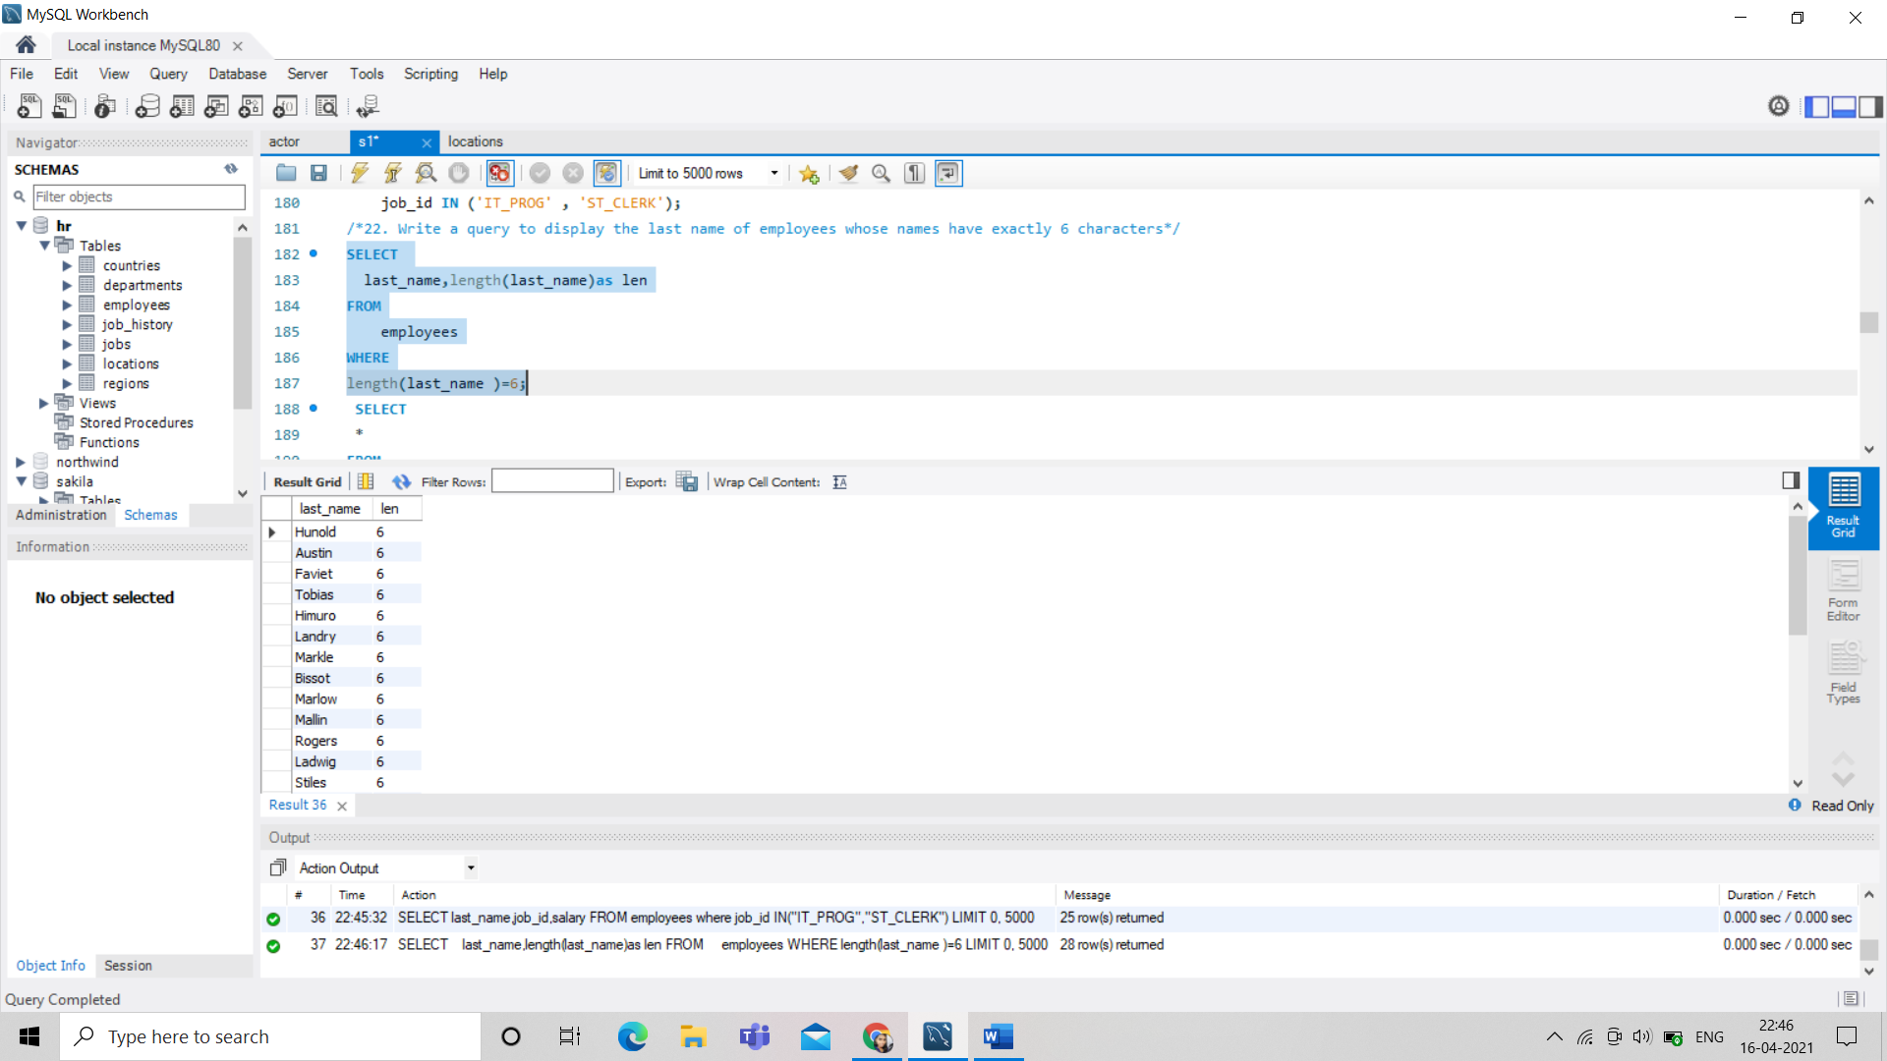

/*24. Write a query to get the job_id and related employee's id

Partial output of the query :

job_id Employees ID

AC_ACCOUNT206

AC_MGR 205

AD_ASST 200

AD_PRES 100

AD_VP 101 ,102

FI_ACCOUNT 110 ,113 ,111 ,109 ,112*/

select job_id,group_concat(employee_id) as "Empoyees ID" from employees group by job_id;

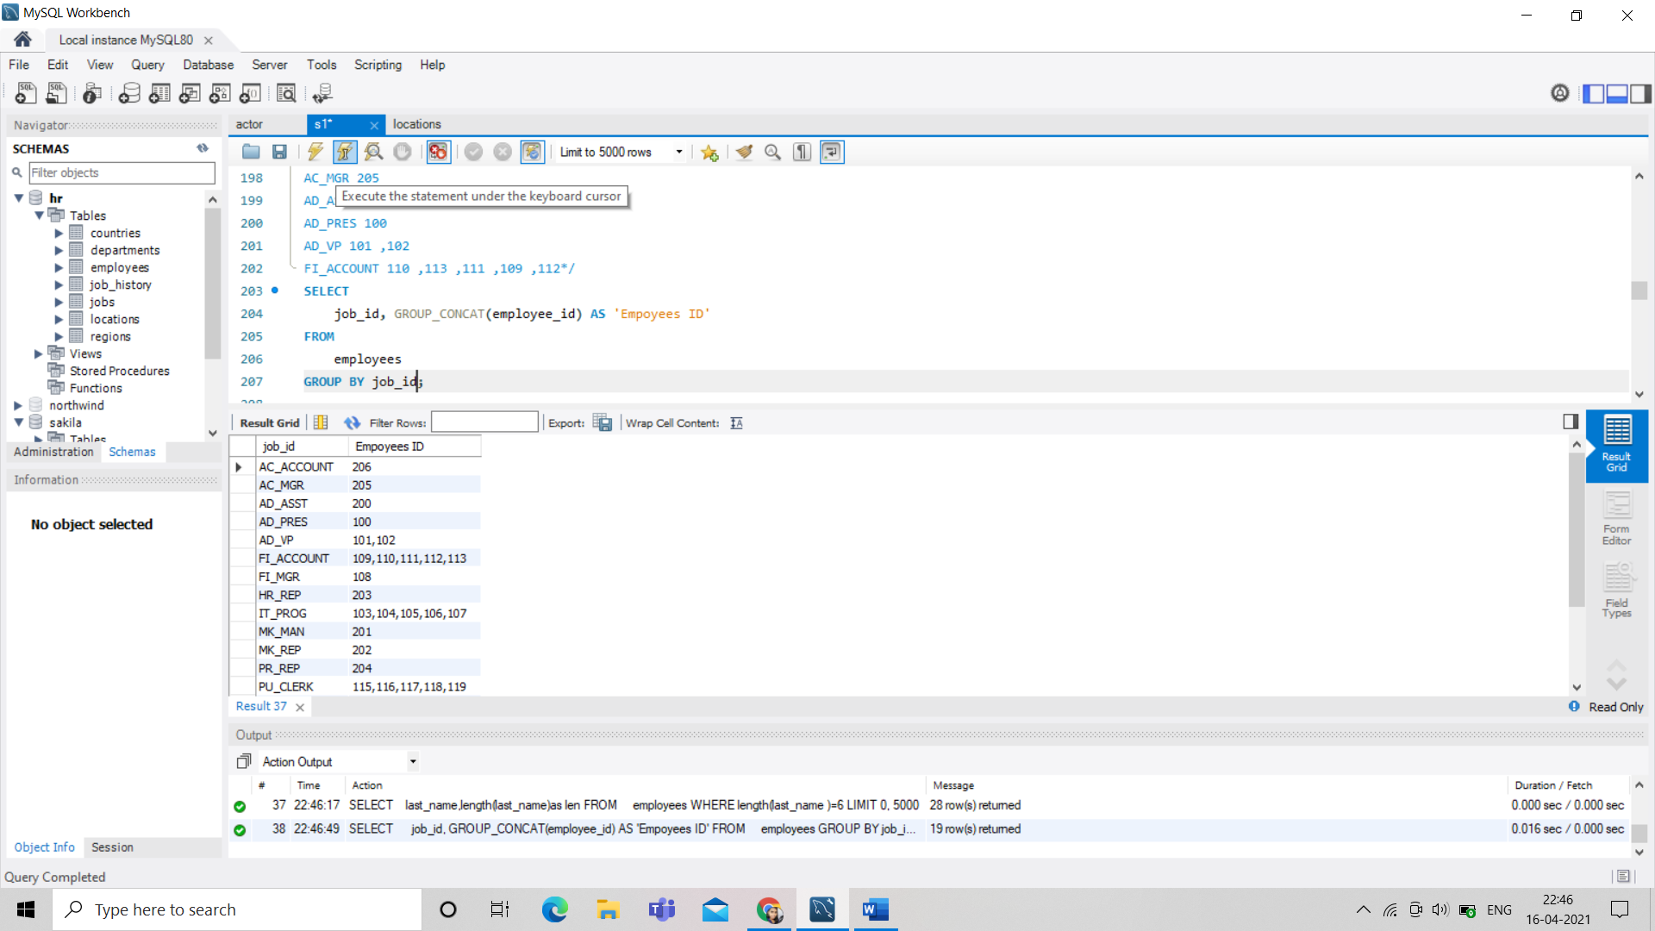

/*25. Write a query to update the portion of the phone_number in the employees table, within the phone

number the substring '124' will be replaced by '999'

*/

UPDATE employees SET phone_number = replace(phone_number,'123','999') where phone_number like '%124%';

UPDATE employees

SET phone_number = REPLACE(phone_number, '124', '999')

WHERE phone_number LIKE '%124%';

/*26. Write a query to get the details of the employees where the length of the first name greater than or

equal to 8*/

SELECT

*

FROM

employees

WHERE

LENGTH(first_name) >= 8;

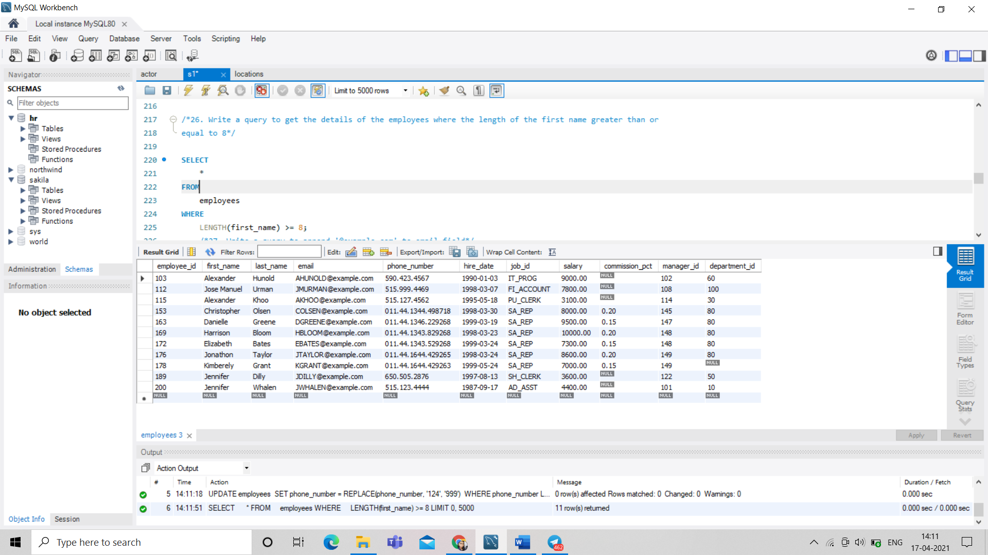

/*27. Write a query to append '@example.com' to email field*/

UPDATE employees

SET

email = CONCAT(email, '@example.com');

/*28. Write a query to extract the last 4 character of phone numbers*/

SELECT

RIGHT(Phone_number, 4) AS 'phone no'

FROM

employees;

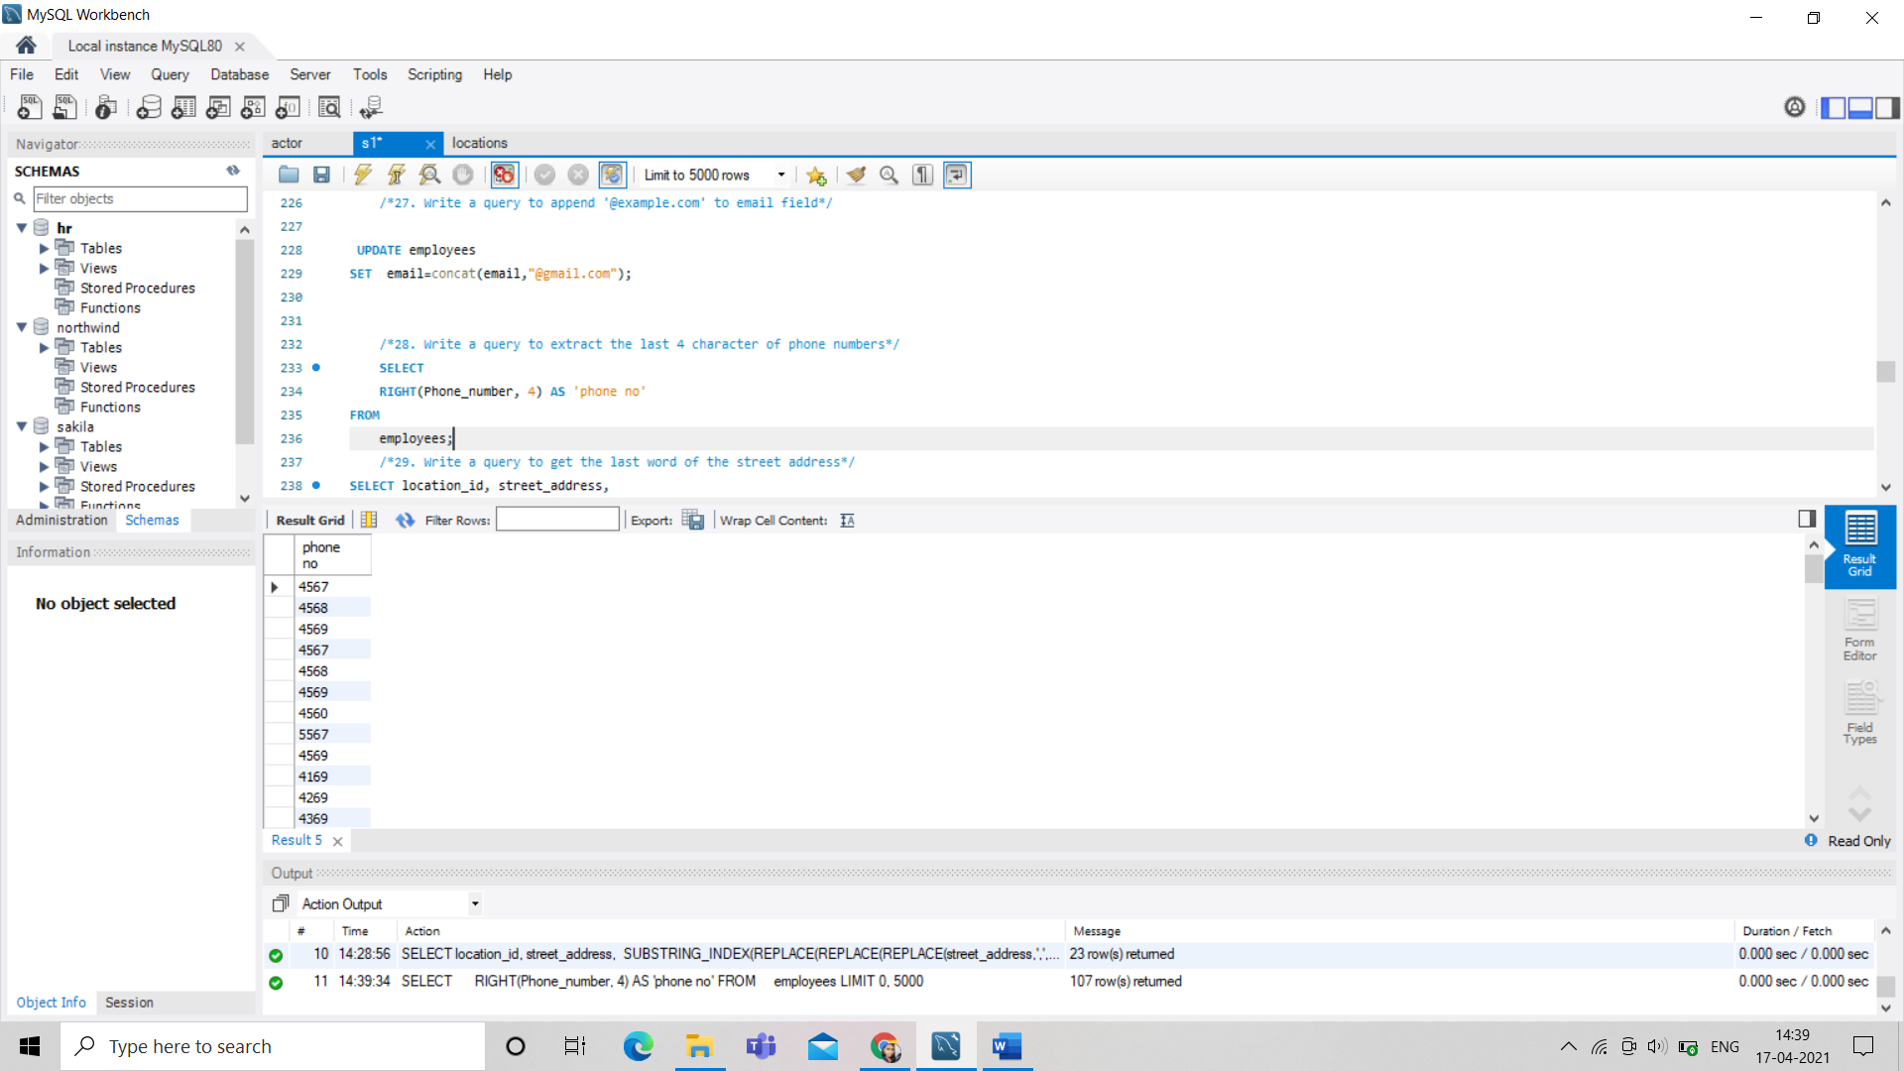

/*29. Write a query to get the last word of the street address*/

SELECT location_id, street_address,

SUBSTRING_INDEX(REPLACE(REPLACE(REPLACE(street_address,',',' '),')',' '),'(',' '),' ',-1)

AS 'Last--word-of-street_address'

FROM locations;

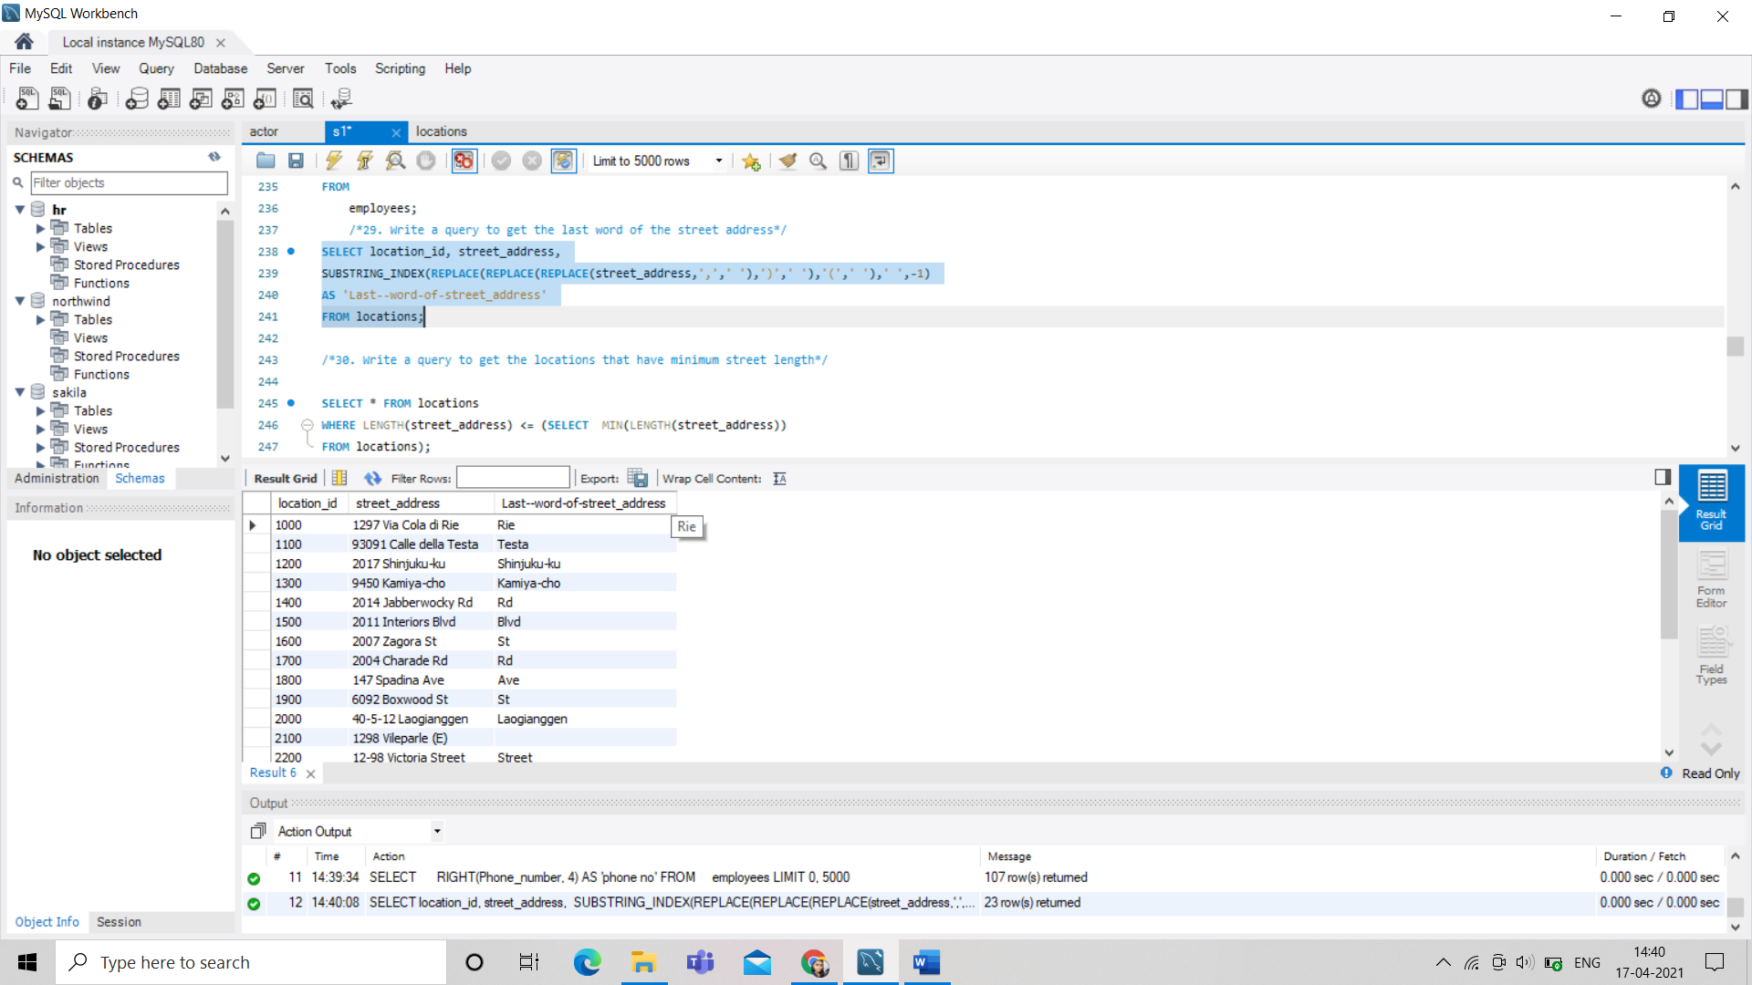

/*30. Write a query to get the locations that have minimum street length*/

SELECT * FROM locations

WHERE LENGTH(street_address) <= (SELECT MIN(LENGTH(street_address))

FROM locations);

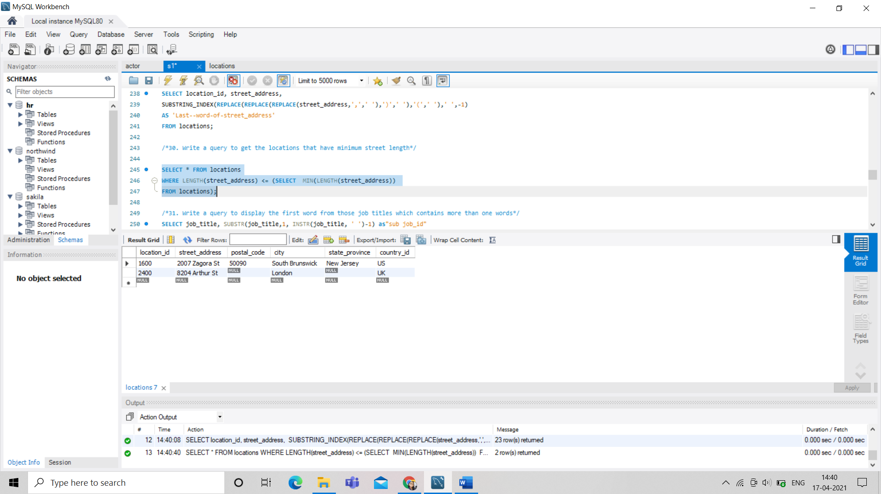

/*31. Write a query to display the first word from those job titles which contains more than one words*/

SELECT job_title, SUBSTR(job_title,1, INSTR(job_title, ' ')-1) as"sub job_id"

FROM jobs;

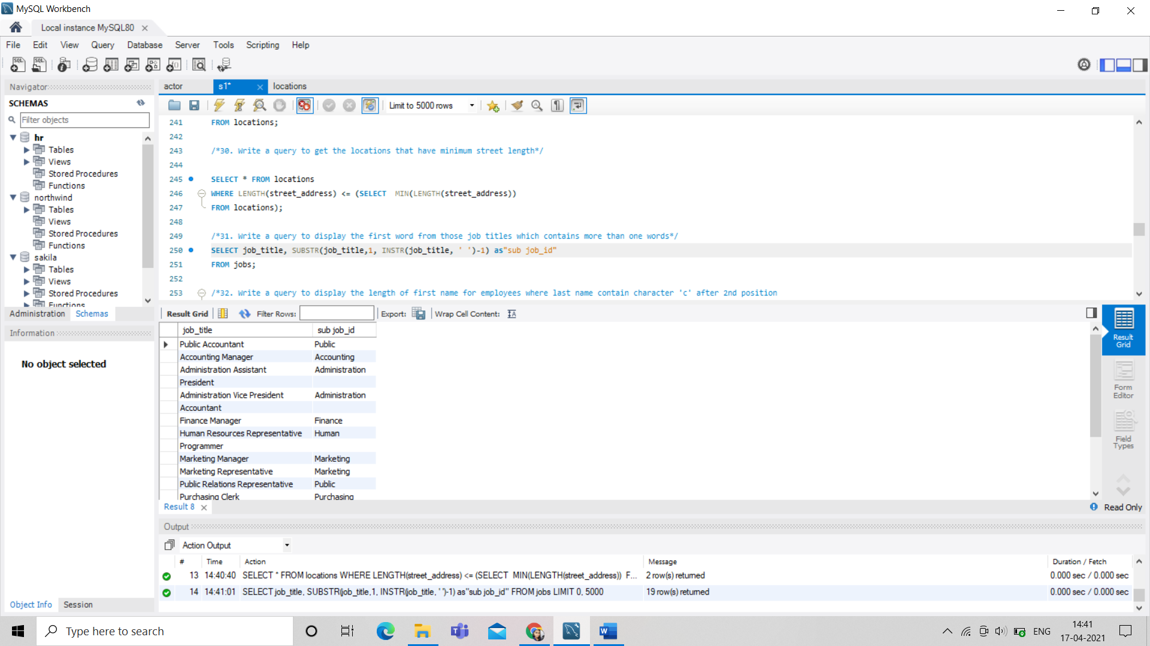

/*32. Write a query to display the length of first name for employees where last name contain character 'c' after 2nd position

*/

SELECT first_name, last_name FROM employees WHERE INSTR(last_name,'C') > 2;

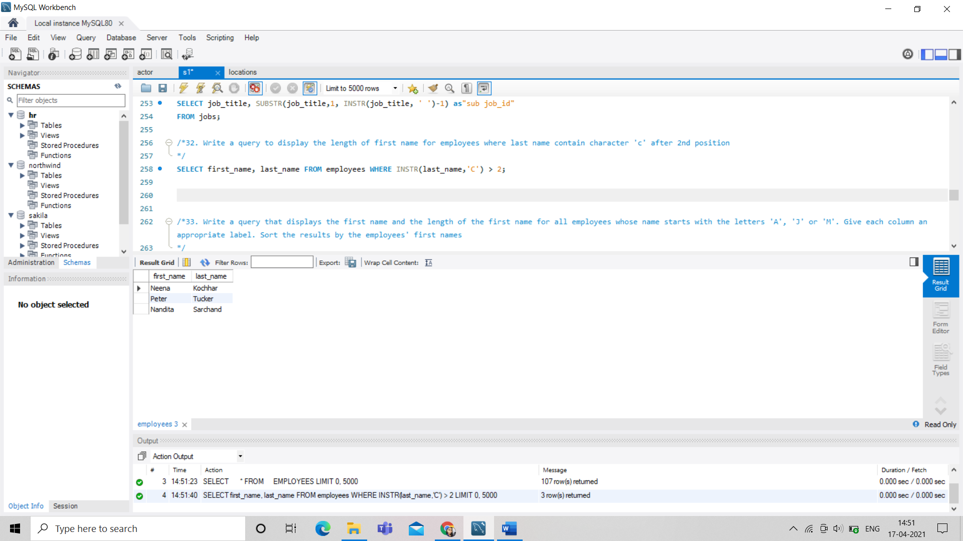

/*33. Write a query that displays the first name and the length of the first name for all employees whose name starts with the letters 'A', 'J' or 'M'. Give each column an appropriate label. Sort the results by the employees' first names

*/

SELECT first_name "Name",

LENGTH(first_name) "Length"

FROM employees

WHERE first_name LIKE 'J%'

OR first_name LIKE 'M%'

OR first_name LIKE 'A%'

ORDER BY first_name ;

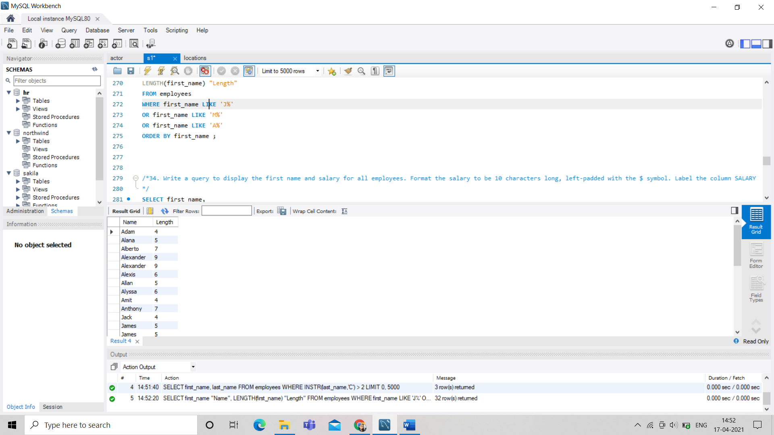

/*34. Write a query to display the first name and salary for all employees. Format the salary to be 10 characters long, left-padded with the $ symbol. Label the column SALARY

*/

SELECT first_name,

LPAD(salary, 10, '$') SALARY

FROM employees;

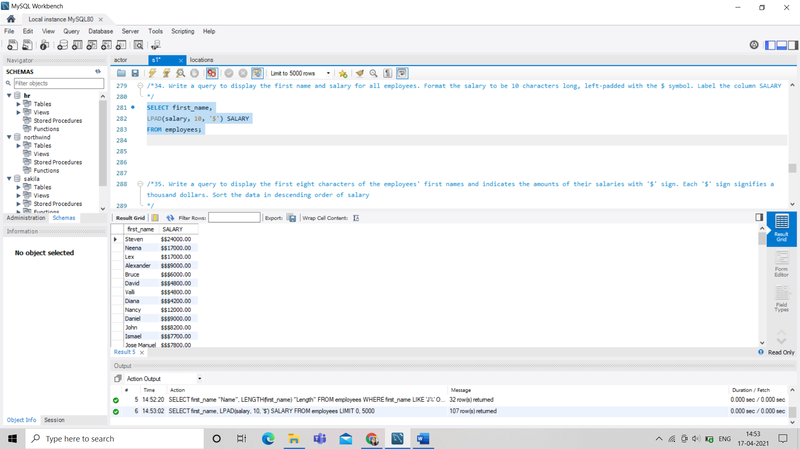

/*35. Write a query to display the first eight characters of the employees' first names and indicates the amounts of their salaries with '$' sign. Each '$' sign signifies a thousand dollars. Sort the data in descending order of salary

*/

SELECT left(first_name, 8),

REPEAT('$', FLOOR(salary/1000))

'SALARY($)', salary

FROM employees

ORDER BY salary DESC;

/*36. Write a query to display the employees with their code, first name, last name and hire date who hired either on seventh day of any month or seventh month in any year

*/

SELECT employee_id,first_name,last_name,hire_date

FROM employees

WHERE POSITION("07" IN DATE_FORMAT(hire_date, '%d %m %Y'))>0;

use northwind;

/* -- Northwind Database Exercises-- */

/*1. Write a query to get Product name and quantity/unit

*/

SELECT ProductName, QuantityPerUnit

FROM Products;

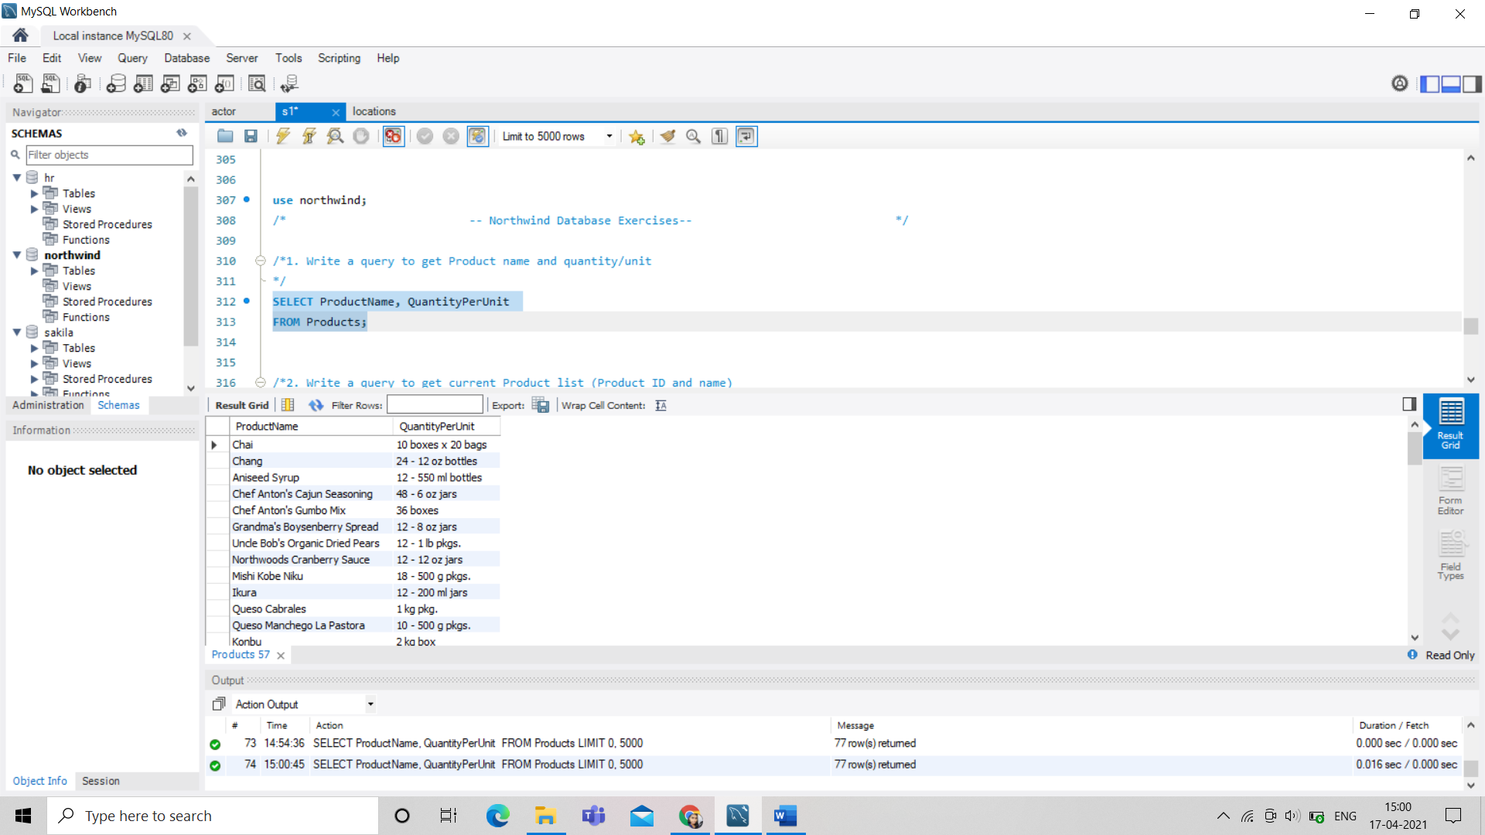

/*2. Write a query to get current Product list (Product ID and name)

*/

SELECT ProductID, ProductName

FROM Products;

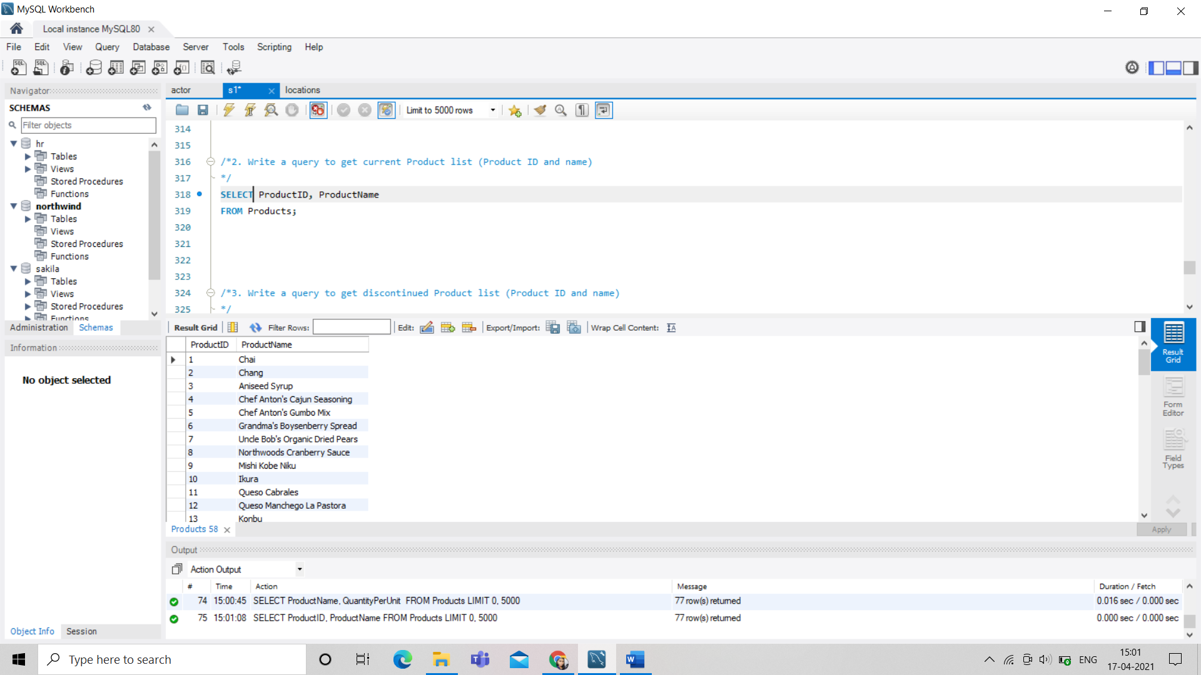

/*3. Write a query to get discontinued Product list (Product ID and name)

*/

SELECT ProductID, ProductName

FROM Products

WHERE Discontinued = 1;

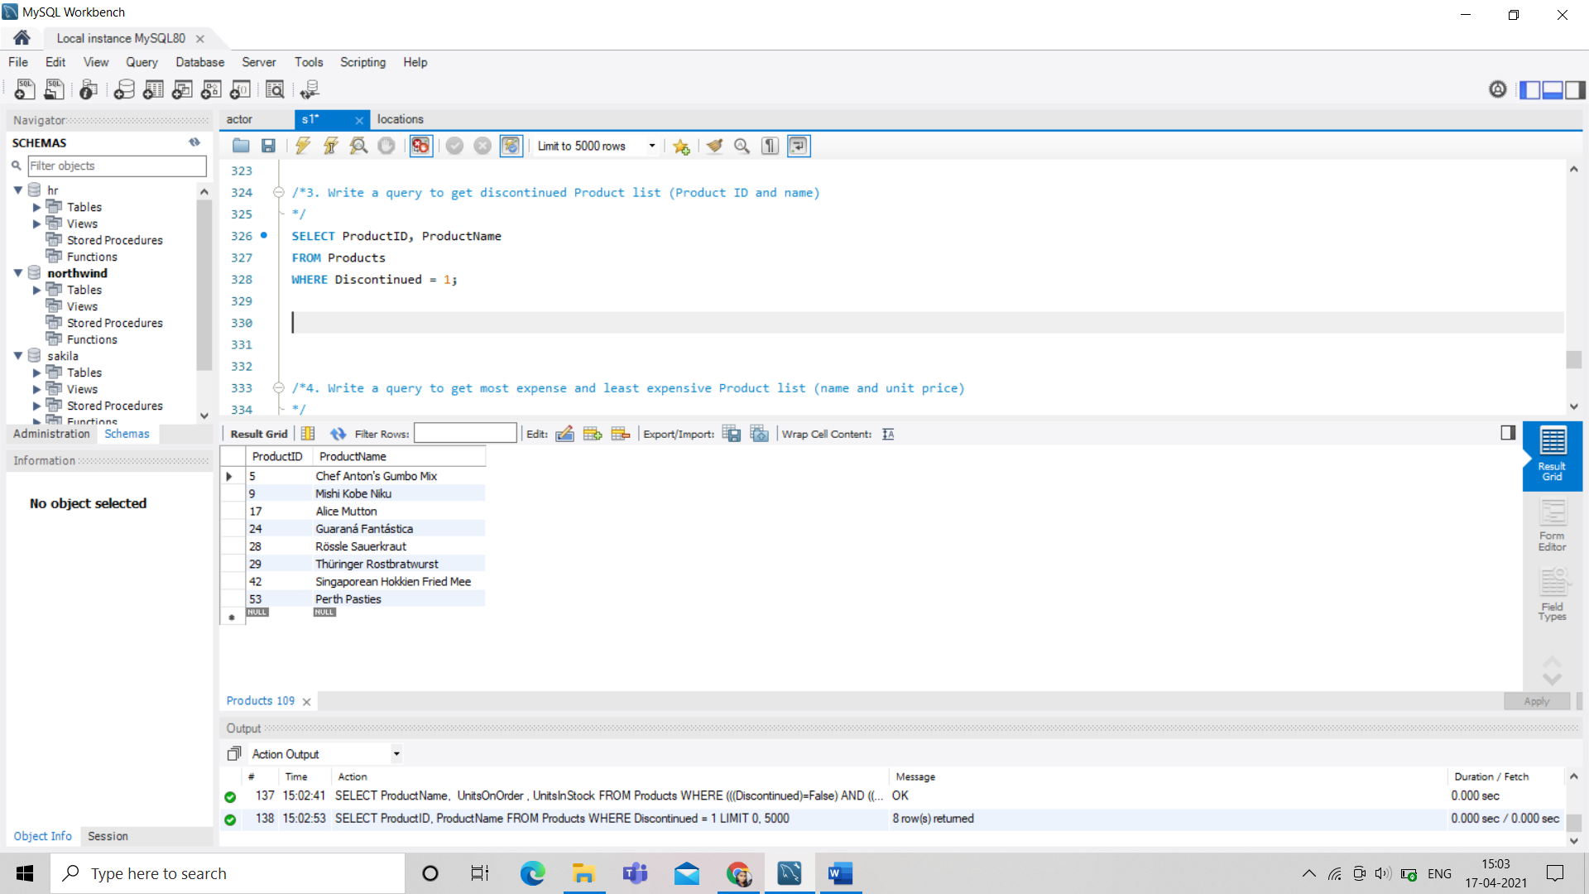

/*4. Write a query to get most expense and least expensive Product list (name and unit price)

*/

SELECT ProductName, UnitPrice

FROM Products

ORDER BY UnitPrice DESC;

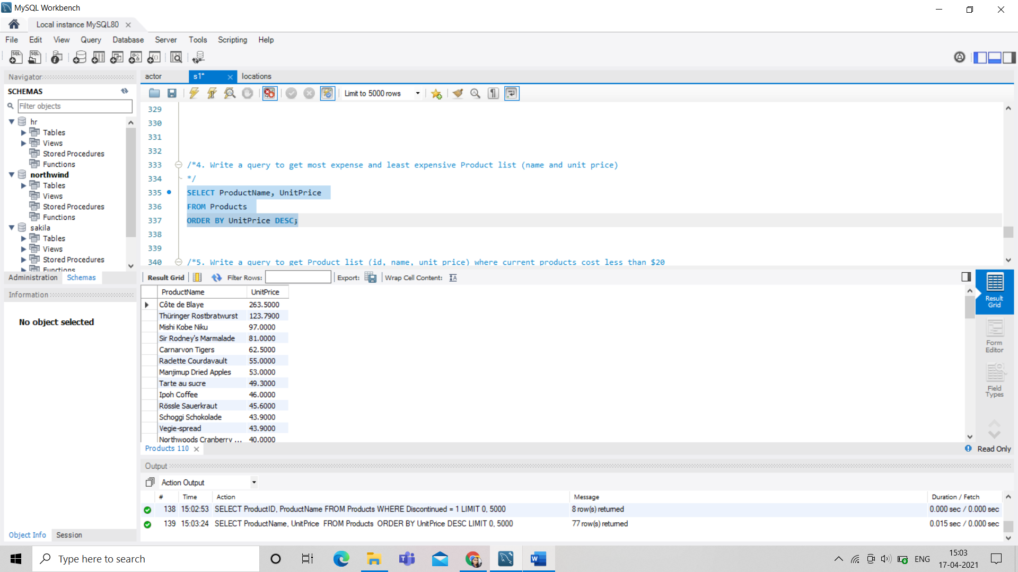

/*5. Write a query to get Product list (id, name, unit price) where current products cost less than $20

*/

SELECT ProductID, ProductName, UnitPrice

FROM Products

WHERE (((UnitPrice)<20) AND ((Discontinued)=False))

ORDER BY UnitPrice DESC;

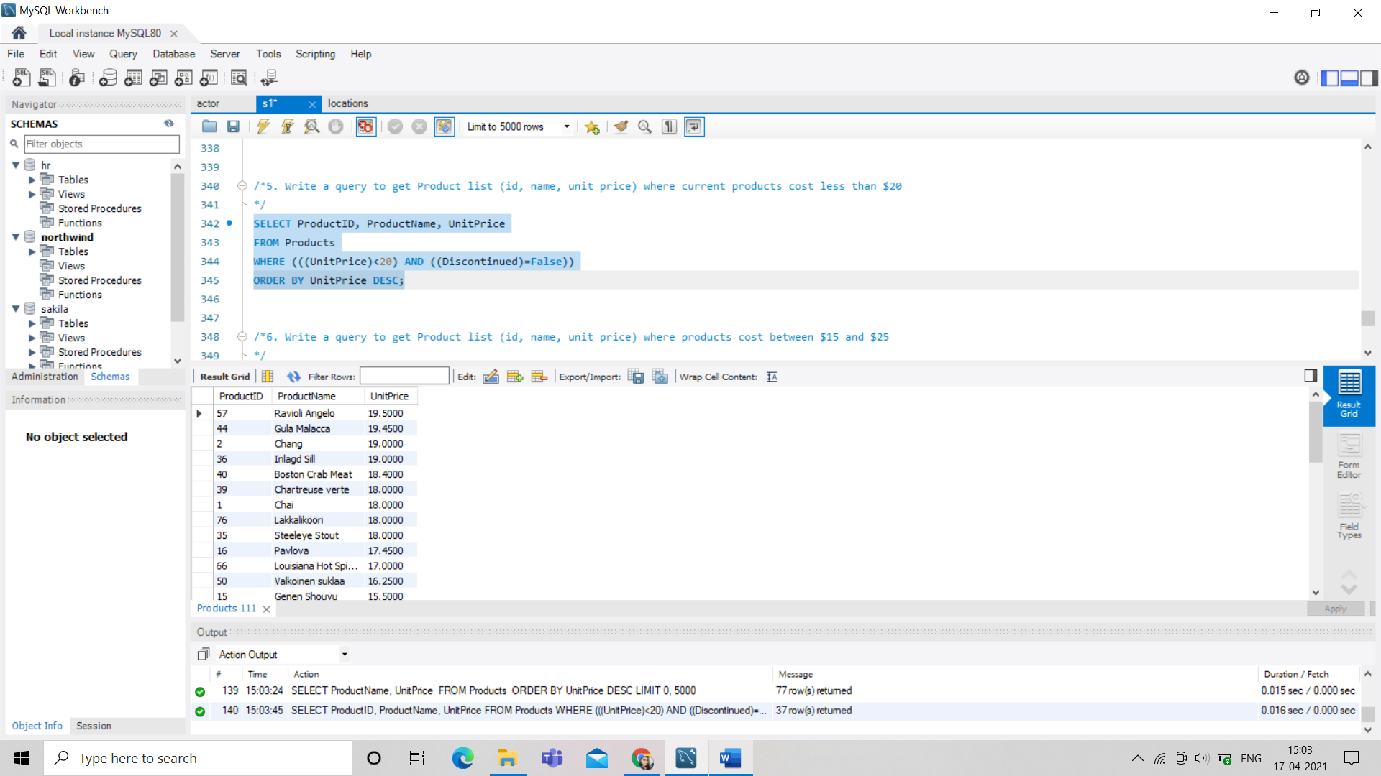

/*6. Write a query to get Product list (id, name, unit price) where products cost between $15 and $25

*/

SELECT ProductName, UnitPrice

FROM Products

WHERE (((UnitPrice)>=15 And (UnitPrice)<=25)

AND ((Products.Discontinued)=False))

ORDER BY Products.UnitPrice DESC;

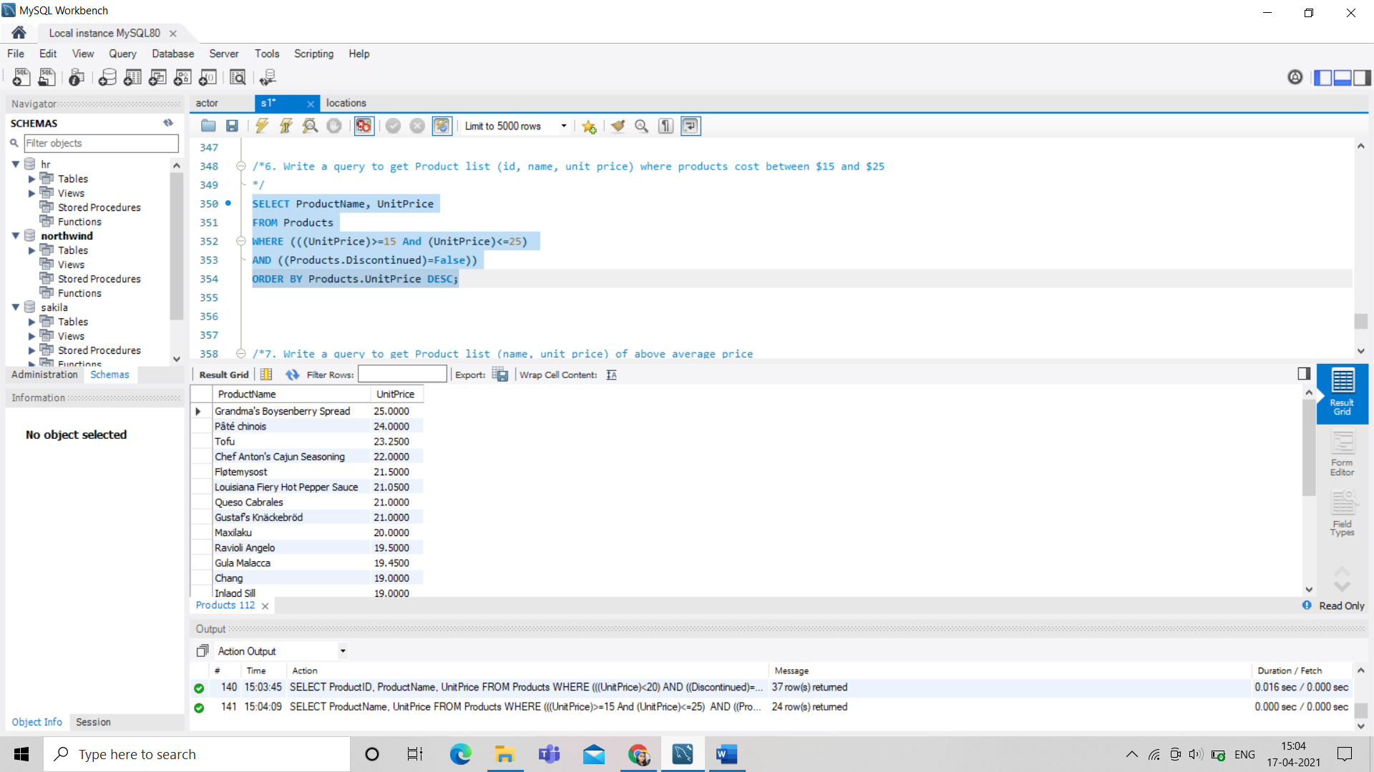

/*7. Write a query to get Product list (name, unit price) of above average price

*/

SELECT DISTINCT ProductName, UnitPrice

FROM Products

WHERE UnitPrice > (SELECT avg(UnitPrice) FROM Products)

ORDER BY UnitPrice;

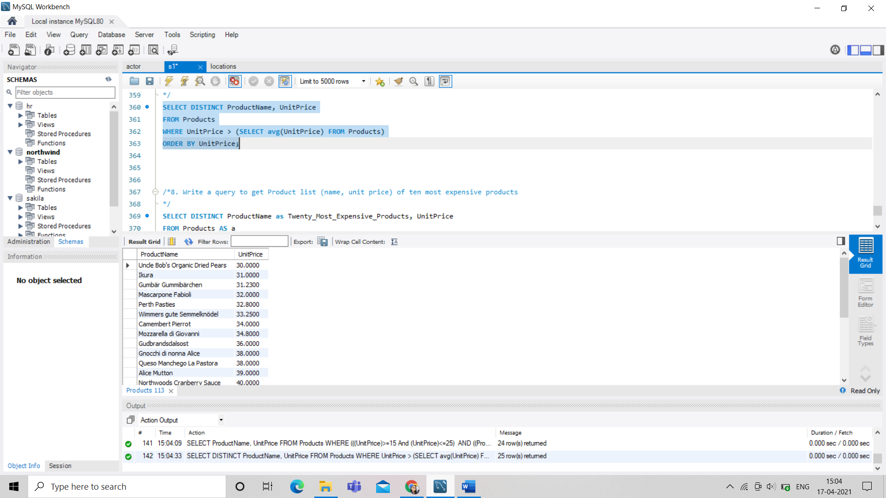

/*8. Write a query to get Product list (name, unit price) of ten most expensive products

*/

SELECT DISTINCT ProductName as Twenty_Most_Expensive_Products, UnitPrice

FROM Products AS a

WHERE 20 >= (SELECT COUNT(DISTINCT UnitPrice)

FROM Products AS b

WHERE b.UnitPrice >= a.UnitPrice)

ORDER BY UnitPrice desc;

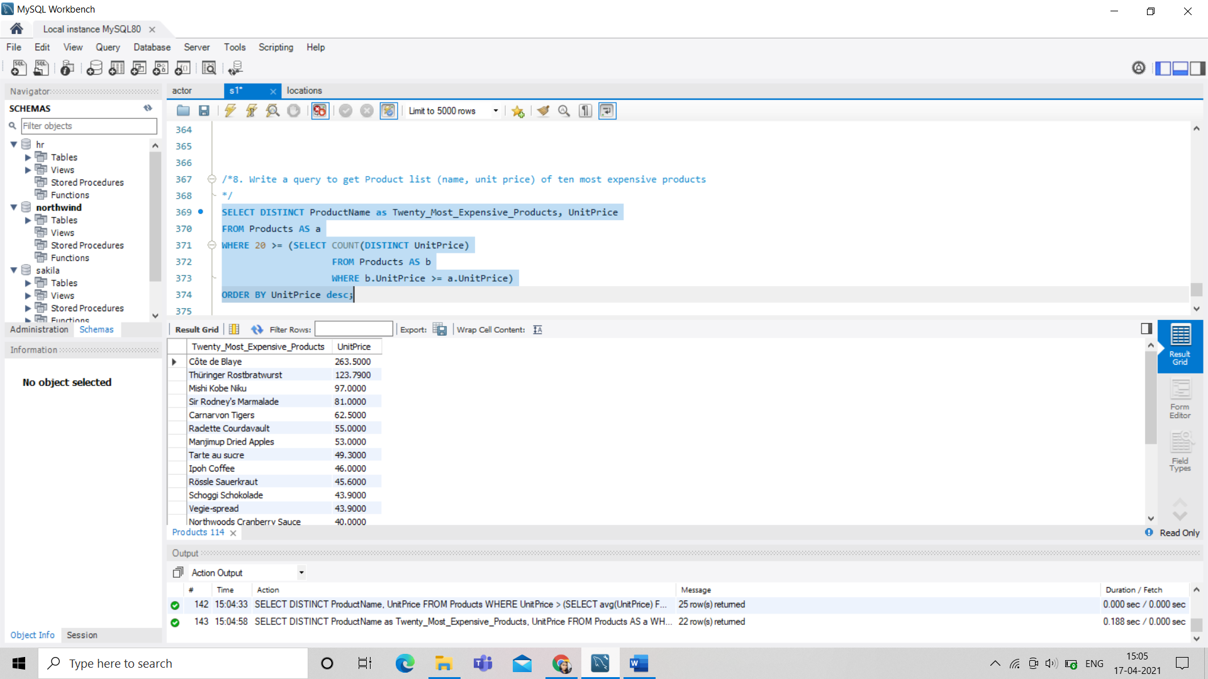

/*9. Write a query to count current and discontinued products

*/

SELECT Count(ProductName)

FROM Products

GROUP BY Discontinued;

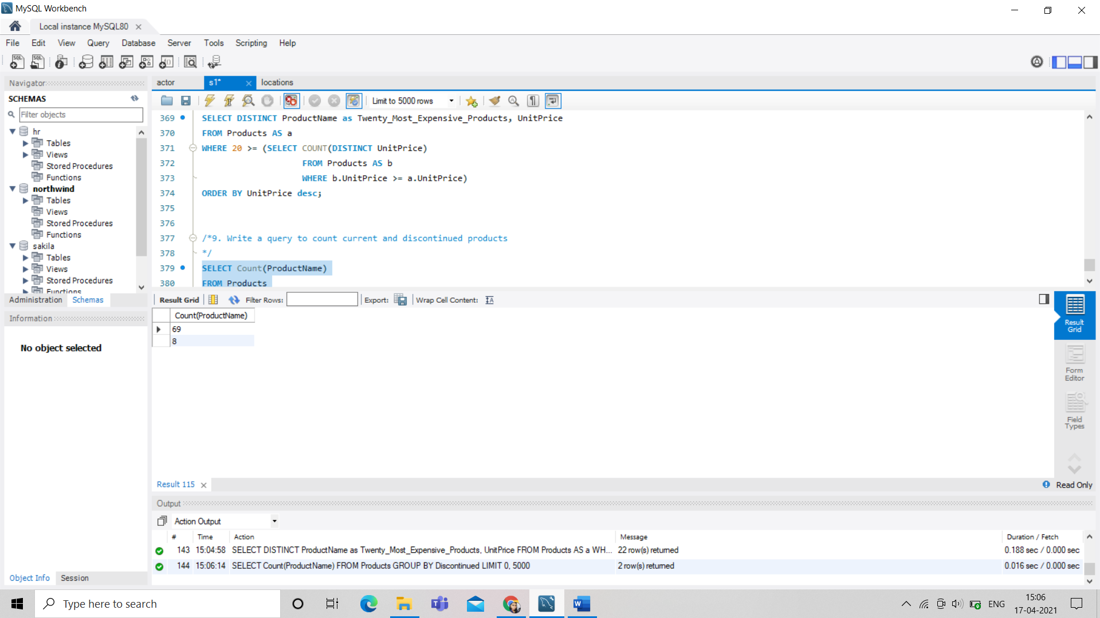

/*10. Write a query to get Product list (name, units on order , units in stock) of stock is less than the quantity on order

*/

SELECT ProductName, UnitsOnOrder , UnitsInStock

FROM Products

WHERE (((Discontinued)=False) AND ((UnitsInStock)<UnitsOnOrder));

